Master Thesis

**How to Distribute New Solar Systems in Europe to Reduce Power Generation Variability**

Department Environmental Systems Science / Earth Sciences, ETH Zürich

Institute for Atmospheric and Climate Science

Supervisors:

Dr. Jan Wohland, Institute for Environmental Decisions, ETH Zürich

Dr. Doris Sylvia Folini, Institute for Atmospheric and Climate Science, ETH Zürich

Dr. Stefan Pfenninger, Institute for Environmental Decisions, ETH Zürich

Prof. Dr. Martin Wild, Institute for Atmospheric and Climate Science, ETH Zürich

Submitted by

Dirk Mühlemann

13-732-037

Uster, 01/05/2021

Abstract

To reduce greenhouse gas emissions and combat climate change, the electrical power production sector is facing a fundamental transition from conventional fossil to renewable technologies. The transition has already started, which can be seen by the great effort and ambitious targets of many nations around the globe. Installed power production capacities of solar photovoltaics (PV) are increasing every year and are already capable of producing around 5.5% of the Europeans electricity demand. Since PV power output depends on weather and climate, it exhibits a highly variable production pattern. This variability challenges the electricity grids because the stability of the grids depends on balanced supply and demand. Further massive deployment of PV systems could lead to an increase of the variability and therefore add to this challenge. Different studies suggest strategies to reduce the PV power output variability on rather short (minutes to hours) or long (seasonal) timescales. However, weather regimes lasting several days influence the PV power output across Europe as well, and knowledge of its impact on multiday PV power output variability is still limited.

Within this thesis, we identify spatial distributions of newly installed PV systems that minimize the multiday power output variability in Europe. To quantify the variability, we perform empirical orthogonal function (EOF) analyses of geopotential height at 500hPa, which reflects weather regimes and therefore has an indirect effect on the PV power output. The geopotential height field is taken from the ERA5 reanalysis dataset which covers the time period from 1979 to present. The resulting subspace spanned by the leading 14 EOFs (explains ~90% if the variance) of our analysis is grouped in seven different weather regimes with the k-mean clustering techniques. To assess the PV power output variability the resulted regimes are linked to country specific PV capacity factors. We use hourly PV capacity factors provided by the simulation of renewable.ninja from 1985-2019. Connecting the regimes with the PV capacity factors leads to an overview of under- and overproduction (relative to the mean) per country and weather regime. Current and planned (NECPs 2030) installed capacity of PV systems in Europe is used together with our findings to assess the current and future multiday PV power output variability in Europe. Furthermore, an optimal (linear least square fit) distribution of additional PV systems is calculated which minimize the multiday variability.

The mean variability, which is the average change of PV power production from one weather regime to another, currently (2019) amounts to 0.9 GW. Whereas the current maximum variability, which is the change of PV power production from the weather regime with the highest PV production to the one with the lowest production, amounts to 3.0 GW. We estimate that with the planed installed PV capacity distribution of the NECPs this is expected to triple by 2030 to 2.7GW and 8.5GW, respectively. Estimates for the year 2050 emphasise that the mean variability could increase from 6.4 GW up to 63.2 GW (depending on the scenario) and the maximum variability could even increase from 20.1 GW to 198.6 GW. We could show that a reduction of the variability for different scenarios of future installed PV capacity distribution is possible. Our method was able to reduce the mean variability up to 44.4 % and the maximum variability up to 38.8 %. The reduction could be achieved by mainly placing the new installed PV capacity to South-eastern and to North-western Europe.

Contents

1. Introduction 6

2. Data & Methods 9

2.1 Data 9

2.1.1 ERA5 9

2.1.2 Renewables.ninja and the Global Solar Energy Estimator (GSEE) 9

2.1.3 Installed PV capacities 13

2.1.4 Electricity consumption data 13

2.2 Method 14

2.2.1 ERA5 data pre-processing 15

2.2.2 Weather regime classification 16

2.2.3 Capacity factors 16

2.2.4 Variability reduction with optimal IC distribution 17

2.2.5 Scenarios 18

3. Results 21

3.1 Weather regimes and their linked capacity factor anomalies 21

3.1.1 Weather regime 0 / NAO+ 26

3.1.2 Weather regime 1 - European trough 26

3.1.3 Weather regime 2 – NAO- 27

3.1.4 Weather regime 3 - Atlantic ridge 27

3.1.5 Weather regime 4 - Atlantic trough 27

3.1.6 Weather regime 5 - European blocking 28

3.1.7 Weather regime 6 - Scandinavian blocking 28

3.1.8 No regime 28

3.2 Installed capacity distributions and their variability 30

3.2.1 Scenario 1 (S1) – PV power production and installed capacities from NECP 2030 31

3.2.2 Scenario 2 (S2) – PV IC in 2050 34

3.2.3 Scenario 3 (S3) – Cost minimization 36

3.2.4 Scenario 4 (S4) –Coverage of country specific electricity consumption with PV systems 37

3.3 Notes 42

4. Discussion 43

4.1 Weather regimes classification 43

4.2 Capacity factor anomalies and surface weather variables 44

4.3 Current and projected PV power production variability 46

4.4 Variability reduction potential 48

4.4.1 S1 48

4.4.2 S2 49

4.4.3 S3 50

4.4.4 S4 50

4.5 Notes 51

5. Conclusion 54

6. Appendix 56

7. References 60

# Introduction

Many governments undertake ambitious climate mitigation efforts to reduce the adverse effect of global warming and thereby try to meet the 1.5°C goal from the Paris agreement (Hulme, 2016). To achieve this goal a transition from conventional fossil to renewable energy technologies is substantial. Solar power generating photovoltaic (PV) systems, as one of the major renewable technologies, has seen a tremendous growth in recent years. According to the PV status report (2019) by the European commission, there was a global installed capacity of 520GW by the end of 2018. By the end of 2019, the installed capacity is expected to reach 650GW, which allows the PV systems to produce roughly 4% of the global electricity demand. Europe's share of installed PV capacity at the end of 2018 was about 117GW, which allowed to produce 5.5% of Europeans electricity demand. Furthermore, recent scenarios for the necessary installed PV capacity if the world is to reach 100 % renewable electricity production in 2050, suggest that the PV installed capacity must rise to more than 4TW by 2025 and 21.9TW by 2050. For Europe this would imply an PV installed capacity of 630GW by 2025 and 1.94TW by 2050 (Jäger-Waldau, 2019).

→ plan from NCEP for 2030

-→ other studies i.e. IRENA → 0.8TW

PV power output depends on weather and climate and therefore challenges the current power grid by variable power input (Graabak & Korpås, 2016; Stram, 2016). → Drücke 2020 James 2007

Within minutes, the power production from a PV system can vary by as much as 80% due to passing broken cloud cover (Mills & Wiser, 2010). There is also a diurnal cycle with highest power production during the day and no production during night. By analysing multiday fluctuation, a relation between long lasting weather regimes and PV power production can be observed. During one weather regime the PV production pattern varies substantially to the next weather regime (Grams et al., 2017). Furthermore, variability in the PV power production is caused by the seasonal cycle (Heide et al., 2010). The efficiency of a PV panel is mainly dominated by the available surface solar radiation and the panel temperature (Huld et al., 2010). Since the seasonal cycle affects both, a direct effect can be observed. Even decadal to multidecadal analyses suggest that global warming and solar brightening/dimming influences the PV power output. Solar brightening/dimming is often caused by air pollution patterns, which influences the available surface solar radiation and therefore affects the PV power output. Global warming leads to an increase of panel temperatures and reduces the efficiency of the panels (Sweerts et al., 2019; Wild et al., 2015).

A stable power grid depends on balanced electrical supply and demand (Stram, 2016).

Frequency example → what happens if not!?? → Hirth and Ziegenhagen 2015, Garnier and Madlener 2015

* Energy balancing Kiviluoma 2012

Short time scale variability due to passing broken cloud cover can affect one PV system substantially. But wider geographical distribution of multiple interconnected PV systems can significantly smooth this short time PV power output variability (Delucchi & Jacobson, 2011; Graabak & Korpås, 2016). Co-deployment of renewable energy system (water, wind and solar) can counteract the variable power output caused by diurnal and seasonal cycles. The basis for these approaches is the different diurnal and seasonal production pattern of water, wind and solar power plants. For example, wind power output exhibits highest production rates during winter whereas solar power production is highest in summer. Co-deployment of wind and solar can therefore reduce the seasonal power production variability. Other combination are possible as well (Graabak & Korpås, 2016; Heide et al., 2010; Santos-Alamillos et al., 2015). To summarize, different studies already have proposed methods to reduce short, diurnal or seasonal solar power production variability.

Fewer studies have investigated in reduction of multiday solar power output variability from a meteorological standpoint. → expalain how? → 500hPa gph anomalies Cassou etc.

* Bloomfiled 2020 TCTs
* Thornton 2017

Grams *et al.* (2017) did but rejected the idea to further invest in it, based on their findings that it would need a tenfold increase of installed PV capacity in Europe to be comparable to the variability of wind power output. Therefore, they focused their study on wind and concluded, that spatial deployment of wind fleets based on information of different weather regimes can reduce the wind power output variability within Europe substantially. Nevertheless, they showed that connecting weather regime to PV power output variability is also possible. Even though the decision to focus on wind rather than solar power output variability is comprehendible, calculations of necessary future installed PV capacities gives reason to do the investigations anyway. Ram *et al.* (2017) estimated that the installed PV capacity for a 100% renewable scenario in Europe must rise to 1.94TW by 2050. The International Renewable Energy Agency (IRENA) estimated Europa’s share a bit lower to 0.89TW. This is roughly a ten to twentyfold increase of installed PV capacity compared to the 87.19GW installed PV capacity used in Grams *et al.* (2017) study. Therefore, the impact of multiday PV power output variability caused by different weather regimes could also become substantial, which makes investigation of the optimal spatial deployment of future PV systems in Europe before further massive deployment of great interest. The results could support current planning activities and could help to reduce future grid balancing problems.

* Timescale discussion necessary?
* Stress events → example? Bloomfield 2018 2020 and der Wiel 2019
* Demand and production pattern → countries with highest demand and production

IRENA 0.784TW EU and 0.107 rest of Europe

Short-term forecasting of solar power (PV) is much less developed as installed capacities are relatively small compared to installed wind power.

# Data & Methods

Chapter 2 first describes the datasets which are the underlying sources of this study (section data). Afterwards it illustrates how the datasets are used to achieve the objective of reducing PV power output variability in Europe in the section method.

## Data

### ERA5

The reanalyse dataset, [ERA5](https://cds.climate.copernicus.eu/cdsapp#!/dataset/reanalysis-era5-pressure-levels?tab=overview) (Hersbach et al., 2018), which is published by the European Centre for Medium-Range Weather Forecasts (ECMWF), is used as source for the weather regime definition. It provides atmospheric, land and oceanic variables from 1979 to present with a temporal resolution of an hour. The grid of ERA5 has a horizontal spatial resolution of 0.28 degrees (~31km) and 37 pressure levels in the vertical. A detailed documentation about ERA5 reanalyse dataset can be found on the ECMWF confluence web page (Hennermann & Yang, 2018).

We use the 500hPa geopotential height variable from ERA5 in the domain 80°W to 40°E, 30°N to 90°N. Geopotential height relates to low and high pressure systems (cyclones / anticyclones) and are commonly used for weather regime classification (Cassou, 2008; Grams et al., 2017; Michelangeli et al., 1995). The domain specification is reasonable for our meteorological field investigates since it captures the largescale circulation that affects Europe. The hourly dataset covers the time from 01.01.1979 until 31.05.2020, which yields in 363’048 datapoints. Additionally, the [ERA5-Land](https://cds.climate.copernicus.eu/cdsapp#!/dataset/10.24381/cds.e2161bac?tab=overview) (Muñoz Sabater, 2019) hourly data from 01.01.1981 until 31.05.2020 are used to get an overview of 2m temperature and surface solar radiation of the classified weather regimes. It is explicit designed for surface application and provides a more accurate dataset for this framework as ERA5. Especially over complex terrain (orography) the ERA5-Land adds value to the ERA5 surface field. Furthermore, ERA5-Land has a higher spatial resolution of 0.1 degrees (~9km) (Muñoz Sabater, 2019). We choose a slightly coarser resolution of 0.25 degrees, comparable to the 0.28 degrees of geopotential height.

### Renewables.ninja and the Global Solar Energy Estimator (GSEE)

Renewables.ninja ([www.renewables.ninja](http://www.renewables.ninja/)) is an interactive web platform that simulates hourly power output of wind and solar power plants all over the world. To calculate the PV power output, it uses the so-called Global Solar Energy Estimator (GSEE). The source code of the GSEE is freely available on [GitHub](https://github.com/renewables-ninja/gsee) and a detailed description of the GSEE can be found in Pfenninger and Staffell (2016). The theoretical background of the GSEE is based on Huld *et al.* (2010). The following variables are the key input parameter of this method to estimate the energy yield of PV modules:

1. Direct and diffuse irradiance at the PV panel
2. Panel temperature

Pfenninger and Staffell (2016) use three data sources to estimate these variables: The two reanalysis datasets of Modern-Era Retrospective analysis for Research and Applications (MERRA and MERRA-2) and the Surface Solar Radiation Data Set - Heliosat (SARAH). Figure 1 shows the general approach of GSEE.

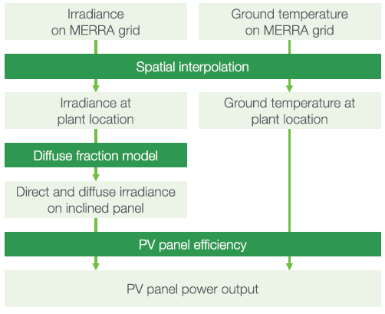

**Figure 1:** Overview of the approach used to model PV power output (Pfenninger & Staffell, 2016).

Since the estimates with MERRA are no longer provided by renewables.ninja we will hereafter only discuss the two datasets MERRA-2 and SARAH. Both are provided in hourly intervals from 1985-2016. SARAH is satellite-derived irradiance dataset with a high spatial resolution of 0.05° × 0.05° whereas MERRA-2 is a reanalysis dataset with a lower spatial resolution of 0.5° latitude and 0.625° longitude. MERRA only provides direct irradiance, but diffuse irradiance is needed as well. Therefore, they used the Boland-Ridley-Lauret model to estimate the diffuse irradiance (Ridley *et al.* 2010; Lauret *et al.* 2013). Since SARAH provides direct and global irradiance no further estimates were needed. Additionally, they use 2m temperature from MERRA-2 as estimates for the ambient temperature. To get the panel temperature they used the ambient temperature of MERRA-2 and additionally considered the effect of the irradiance on the panel temperature. This relation was estimated with site measurements of one of their sources (DTI see below). This dataset provides ambient and panel temperature for each site with which they derived an empirical relationship.

It is more common and easier to make comparison and analyses of PV power output with capacity factors rather than with absolute power output and we use this approach as well. The unit-less capacity factor CF is defined as:

|  |  |  |
| --- | --- | --- |
|  | $$CF=\frac{P}{IC}$$ | Eq. 1 |

where P is power output [W] and IC is the installed capacity [W].

MUSS MEHR KOMMEN

To evaluate the results obtained with the method described above, Pfenninger and Staffell (2016) compared it with capacity factors based on site measurements. To obtain the measured capacity factors they used three sources: DTI, PVLog.de and PVOutput.org. Over 1000 site data (measurements from PV systems) were collected from these three sources. Figure 2 shows a histogram of the difference between measured capacity factors and capacity factors simulated with the GSEE.

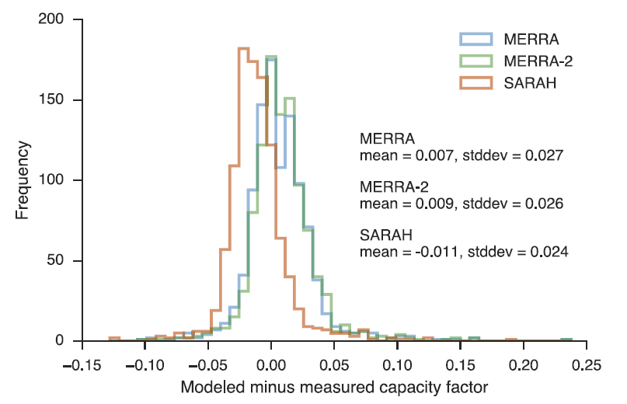**Figure 2**: Histogram of the difference between the three modelled and measured capacity factors. Negative values infer underestimates of the capacity factor and positive values overestimates. The blue graph corresponds to modelled data with MERRA, the green graph to MERRA-2 and the red graph to SARAH. (Pfenninger and Staffell, 2016)

The mean of this differences is taken by Pfenninger and Staffell (2016) as basis for a bias correction. They used it to calculate one correction factor for each simulation (MERRA, MERRA-2 and SARAH).

Additionally to the power output simulation of a wind or solar plant at a specific location, renewables.ninja also provides capacity factors per country. Pfenninger and Staffell (2016) have performed randomized (tilt and azimuth angel) national-scale simulations with MERRA-2 and SARAH data to estimate averaged capacity factors per country. Also, these data were analysed against the measured site data. The measured capacity factor per country was then calculated as the mean of all capacity factors per site in one country.

This capacity factor per country suits perfect for our need of analyizng PV power output variability and its reduction potential.

But one must consider that this is strongly depended on the amount and position of measurement sites in a country. For example, for Spain they only have 14 available measurement sites that are mostly located at the northern coast. This leads to a statistically unrepresentative sample (Pfenninger & Staffell, 2016). Nevertheless, a further advantage of this approach is to be in line with the study of Grams *et al.* (2017) which makes further comparison or combination analyses of wind and solar power output variability easier.

We use the capacity factor per country within our thesis to achiev the goal of reduction of PV power output variability within Europe.

Since our study focusses on the reduction of PV power output variability within Europe, we operate with rather large-scale and long-term quantities. Therefore we make use of the capacity factors per country by Pfenninger and Staffell (2016)

We use this capacity factor per country to achieve the goal of reducing the PV power output variability. The benefits from SARAH are the higher spatial resolution and it is more precise in estimating the energy yield of PV panels on hourly to daily time scales than MERRA-2 (PFENNINGER). But it suffers from a significant amount of missing data. Especially prior to 1995 the lack of data prevents long-term consistency.

### Installed PV capacities

Data from the International Renewable Energy Agency (IRENA) are used to gather the current installed PV capacities (2019) for each country in Europe. *“IRENA is an intergovernmental organisation that supports countries in their transition to a sustainable energy future, and serves as the principal platform for international co-operation, a centre of excellence, and a repository of policy, technology, resource and financial knowledge on renewable energy”* (IRENA, 2020b). The used data can be found in the “Renewable Capacity Statistics 2020” report by IRENA. Together with the capacity factors by renewables.ninja (section 2.1.2) the PV power output for each country are calculated (Eq. 1). Furthermore, the estimates “where we need to be” in 2050 presented in the “Energy Transformation Roadmap to 2050” by IRENA are used as one source for the PV installed capacity in Europe 2050 (IRENA, 2020a). The other sources to estimate the needed PV IC in 2050 are the Energy Watch Group (Ram et al., 2017) and SolarPower Europe (SolarPower Europe and LUT University, 2020).

To further analyse where the PV power output variability is heading to, the National Energy and Climate Plans (NECPs) of each country in the EU are used. Within the NECPs each country defines the amount of PV systems they plan to install until the year 2030. For the rest of Europe individual national plans are considered or if not found the average PV installed capacity growth rate until the year 2030 from all EU countries is multiply with the current PV installed capacity to get an estimate.

### Electricity consumption data

Electricity consumption data are taken from the open-power-system-data ([opsd](https://open-power-system-data.org/)). For countries which are missing in the opsd dataset, the statistical office of the European Union (Eurostat) is used as source. Since the availability of the data per year differs per country, we take the latest fully reported year for each country as current total electricity consumption (range between 2016 and 2019).

* Table with all IC per country? Consumption? Only countries?

## Method

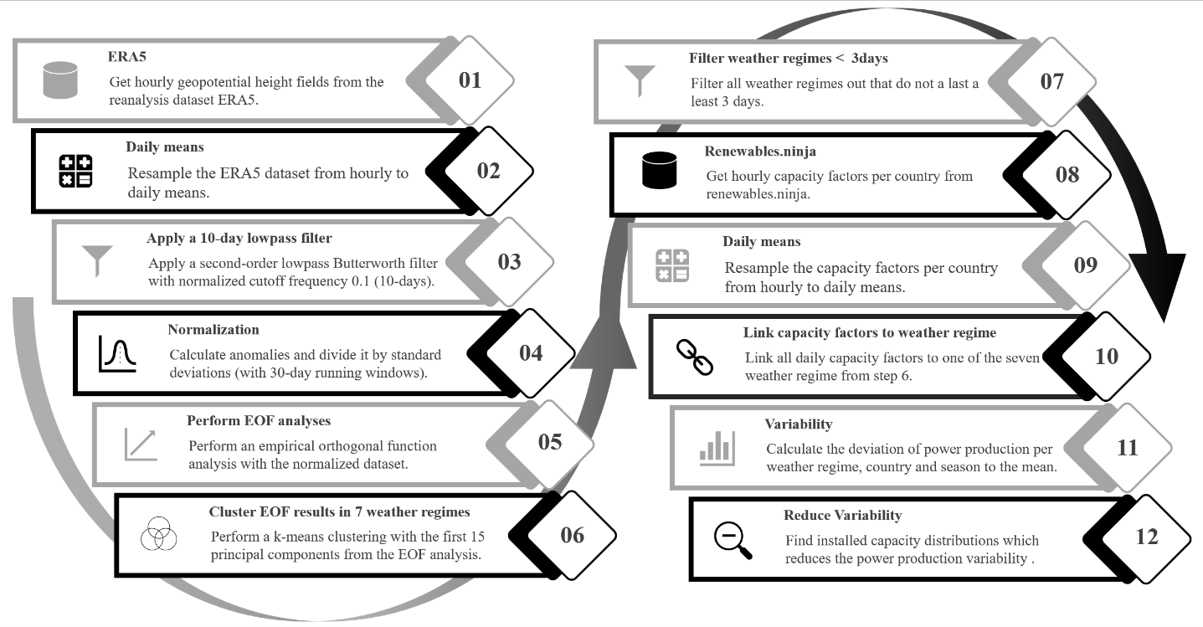

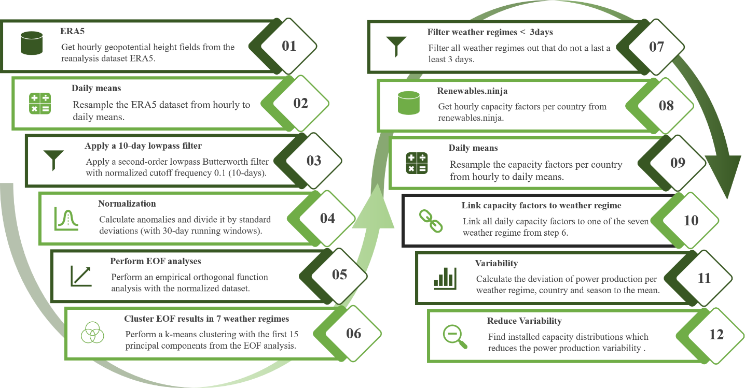

### ERA5 data pre-processing

As first step the hourly geopotential height fields from ERA5 are resampled by calculating daily means because weather regimes typically last several days, and an hourly temporal resolution is not necessary. Furthermore, a 10-day lowpass filter is applied to smooth the data. The input data for the EOF analysis (see section 2.2.2) are standardized anomalies which are calculate with the lowpass filtered daily means:

|  |  |  |
| --- | --- | --- |
|  | $${{std}_{ano}}_{d}=\frac{z_{d}-z_{d,mean}}{z_{d,std}}$$ | Eq. 2 |

where zd are the lowpass filtered daily means of the geopotential height, zd,mean is the climatological mean with a running window of 30 days, and zd,std is the standard deviation of the geopotential height with a running window of 30 days. The running window is defined such as the respective day acts as centre of the window. For instance, to derive the reference climatology for the 15th of January the mean of the first to the 30th January is calculated for every year and grid point. This results in 41 means per grid point since our dataset covers 41 years. These 41 means per grid point are taken again to calculate a mean, so that we finally have one reference climatology for the 15th of January for every grid point. This is done analogous for every day of the year, which yields in 366 sperate reference climatology and standard deviations.

Standardized anomalies are used because of the weather regimes definition year around. Since it includes normalizing with the standard deviation, the amplitude in the anomaly caused by the seasonal cycle is removed prior to the weather regime classification. The used 30-day running window for the reference climatology and standard deviation calculations differs to other studies. Often, investigations are only made for weather regime in winter where a correction for the seasonality is not needed (REF). Others (GRAMS) are using 90-day but since our interest focus on multiday timescale this is rather long and increases the probability that the impact of the signal of the seasonal cycle is rather high.

EVTL PICTURES WITH COMPARISON

### Weather regime classification

For the weather regime classification, the well-known method of empirical orthogonal function analysis and k-means clustering is used (Cassou, 2008; Michelangeli et al., 1995). An EOF analyses decomposes a dataset into statistically orthogonal modes that describe the variability of the data. For metrological datasets, a few modes are often sufficient to explain a large fraction of the total variability in the data, which is helpful to assess the key patterns of the variability and to further analyse them. We perform the EOF analysis on our pre-processed data with the eofs python package by Dawson (2016).

The resulting first 16 principal components of our EOF analyses, which explained ~90% of the variance, are used to cluster the data into weather regimes. We use the clustering method k-means which is implemented in the python package sklearn.cluster by Pedregosa *et al.* (2011). Generally, clustering techniques are used to group data with similar characteristics by minimizing the variance within the clusters. The difficulty lies in the definition of the number of clusters. For the Euro-Atlantic region often four clusters are used to define the weather regimes (Cassou, 2008; Michelangeli et al., 1995; van der Wiel et al., 2019). The well-studied four weather regimes which are received with this approach are the negative and positive phase of the North Atlantic Oscillation, the Scandinavia high and the Atlantic ridge (EVTL FIG). But most of these studies focus only on wintertime weather regime classification. According to Grams *et al.* (2017) the optimal number of clusters to define weather regime year around is seven which seems to be plausible by a simple check with the elbow and silhouette method (EVTL FIG). Therefore, we use 7 clusters as well which additionally make a comparison/combination with the study by Grams *et al.* (2017) easier. Furthermore, we sort all days out where the weather regime does not last at least 3 days and assign these days to a separate weather regime hereafter called “no-regime”.

To summaries, we use EOF analyses and k mean clustering to derive an assignment for each day of the ERA5 dataset to one of 7 weather regime or to no-regime.

### Capacity factors

The national aggregated CF by renewable.ninja are used, which are provided in hourly intervals. The advantage of this dataset is the included bias correction described in section 2.1.2.

The CF dataset is resampled analogously to the ERA5 dataset to get daily means. Since the CF are highly influenced by the seasonal cycle, they are analysed separately for each season (winter, spring, summer, autumn) (EVTL FIG OF HISTOGRAMM). Together with the weather regime classification, the capacity factor can now be attributed to different weather regimes. The attributed capacity factors are used to calculate a mean capacity factor per weather regime, season, and country. The difference between this mean capacity factors and the mean capacity factors for the whole season of a country determines whether the impact of the weather regime exhibits over- or underproduction (Eq. 3).

|  |  |  |
| --- | --- | --- |
|  | $${∆CF}_{wr,country,season}={CF}_{wr,country,season}-{CF}_{country,season}$$ | Eq. 3 |

where CFwr,country,season is the mean capacity factor of a specific weather regime, country and season [unitless] and CFcountry,season is the mean capacity factor of a country for the whole season [unitless].

Multiplication of capacity factors with installed capacities yields power output (Eq. 1). This can be used to expand Eq. 3 which gives the total deviation of solar power output of Europe per weather regime and season.

|  |  |  |
| --- | --- | --- |
|  | $${∆P}_{wr,Europe,season}=\sum_{country}{\left({∆CF}_{wr,country,season}*{IC}_{country}\right)}$$ | Eq. 4 |

where ICcountry is the installed capacity per country [W] and ${∆CF}_{wr,country,season}$ is the deviation of CF per weather regime, country and season to the seasonal mean [unitless].

Eq. 4 is used as an expression for the variability. If the result of this equations is zero, the PV power production of the respective weather regime and season is equal to the mean PV power production of the respective season and therefore the variability is maximally reduced.

→Explain plot for total variability.

### Variability reduction with optimal IC distribution

To determine an IC distribution which distinctive reduces the PV power generation variability, Eq. 4 for every country, season and weather regime is used in a linear least-square problem with an upper and lower bound on the variables. This is done with the scipy.optimize.lsq_linear python package which solves the following optimization problem:

|  |  |  |
| --- | --- | --- |
|  | $$minimize0.5×∨{A\vec{x}-\vec{b}∨}^{2}subjectlb≤x≤ub$$ | Eq. 5 |

where A is the coefficient matrix, x is the solution found, b is the target vector, lb is the lower bound of the solution x and ub is the upper bound of the solution x.

The coefficient matrix A is defined with ${∆CF}_{wr,country,season}$ from Eq. 3 the following:

|  |  |  |
| --- | --- | --- |
|  | $$A=\left(\begin{matrix}{∆CF}_{WR0,AL,winter} & ⋯ & {∆CF}_{WR0,SK,winter} \\ ⋮ & ⋱ & ⋮ \\ {∆CF}_{WRX,AL,autumn} & ⋯ & {∆CF}_{WRX,SK,autumn}\end{matrix}\right)$$ | Eq. 6 |

where the first element of the matrix ${∆CF}_{WR0,AL,winter}$ is the capacity factor anomaly of weather regime 0, in the Albanian winter. The country persists per column, but it goes through all weather regimes (0-7) and seasons, which gives a total of 32 rows. Per row the matrix goes through all countries, from Albania to Slovakia, which results in 36 columns for the considered countries defined above (→ define somewhere above → table with current IC per country!?).

The target vector $\vec{b}$ is set to zero to reduce the variability within one weather regime and season as much as possible and therefore also reduces the variability from one weather regime to other:

|  |  |  |
| --- | --- | --- |
|  | $$\vec{b}=\begin{matrix}0 \\ … \\ 0\end{matrix}$$ | Eq. 7 |

where $\vec{b}$ has the same length as the number of rows of matrix A.

The result of this method is the vector $\vec{x}$ which contains then the IC for each country:

|  |  |  |
| --- | --- | --- |
|  | $$\vec{x}=\begin{matrix}{IC}_{AL} \\ … \\ {IC}_{SK}\end{matrix}$$ | Eq. 8 |

The method to perform the minimization is the Trust Region Reflective (TRF) algorithm (Branch et al., 1999).

The lower bound is always set to the current (2019) PV IC per country (unless something else is mentioned in the scenarios below). The upper bound is always set to the potential PV IC which is taken from the study by → JAN FRAGEN/NACHSHAUEN PAPER

### Scenarios

This section describes the expansion of the method in section 2.2.4 to depict different scenarios for future PV IC distributions. The underlying goal of all scenarios is to reduce the PV power generation variability but with different constraints. The different constraints are added row/element wise to the coefficient matrix A (Eq. 6) and the target vector $\vec{b}$ (Eq. 7). The newly added rows and elements act as additional equations within our linear least-square problem and their residuals are consequently also minimized.

To meet the requirements of the different scenarios described below and get a better control over our linear least-square problem, we introduce a weighting vector $\vec{w}$:

|  |  |  |
| --- | --- | --- |
|  | $$\vec{w}=\begin{matrix}w_{0} \\ … \\ w_{x}\end{matrix}$$ | Eq. 9 |

where the elements of the vector $\vec{w}$ are the weightings for each of our equations defined with the coefficient matrix A and the target vector $\vec{b}$. The weighting vector is also useful to consider the various orders of magnitudes of our equations. I.e., the first 28 rows are of the same order of magnitude because they all describe the PV power output variability. But this is not the case if we introduce an equation/row which constrains our system to a minimum total European PV power production. Additionally, it must be considered that the method used to solve the linear least-square problem, minimizes the sum of the residuals of the equations. Since our first 32 equations are all about the variability they are already relatively highly weighted compared to one equation we add. With the introduced weighting vector, it is possible to counteract and give more weight to the one added equation if necessary.

To apply the weighting vector to the linear least square problem the square root of its elements is taken as elements of a diagonal matrix and multiplied with the coefficient matrix A and the target vector $\vec{b}$ before the optimization problem is solved. → EQ AUFSCHREIBEN!?

#### Scenario 1 (S1) – PV power production and installed capacities from NECPs 2030

The objective of S1 is to minimize the PV power production variability but the total installed capacities and power production with PV systems in Europe must equal (+/- 1GW) to the ones we estimate if the NECPs for 2030 are fulfilled. This gives a direct comparison of the variability estimated with the plans of the countries in Europe for 2030 to the variability reduction potential we have if distribute the same additional amount optimally to reduce the variability.

To realize S1 two rows and elements are added to the coefficient matrix A and the target vector $\vec{b}$, respectively. The first row adds the constraint that the total IC must be equal to the total IC planned for 2030. This is achieved by adding a row with ones to the coefficient matrix A and the total IC planned for 2030 as element to the target vector $\vec{b}$. The second row considers for the total PV power production. PV power production is calculated by multiplying IC with the CF (Eq. 1). Therefore, we add all the mean CF per country as row to the coefficient matrix A. The total PV power production is added to the target $\vec{b}$. It is calculated as sum of the CF per country multiplied by the planned IC per country for 2030.

|  |  |  |
| --- | --- | --- |
|  | $$A_{S1}=\left(\begin{matrix}⋯ & ⋯ & ⋯ \\ 1 & ⋱ & 1 \\ {CF}_{AL} & ⋱ & {CF}_{SK}\end{matrix}\right)$$ | Eq. 10 |

where $A_{S1}$ is the coefficient matrix for S1 (expansion of Eq. 6) and ${CF}_{AL}$ and ${CF}_{SK}$ are the mean capacity factors for Albania and Slovakia which represents the mean CF for all countries.

|  |  |  |
| --- | --- | --- |
|  | $$\vec{b_{S1}}=\begin{matrix}⋯ \\ {tot}_{{IC}_{2030}} \\ {tot}_{{production}_{2030}}\end{matrix}$$ | Eq. 11 |

where $b_{S1}$ is the target vector for S1 (expansion of Eq. 7), ${tot}_{{IC}_{2030}}$ is the total installed capacity planned for 2030 and ${tot}_{{production}_{2030}}$ is the total PV power production estimated with the planned IC 2030.

The weighting vector for S1 is chosen such that all the equations which consider for the variability are set to one. The weighting of the equation which considers for the total IC are set to XY and the equation which considers for the total PV production is set to XY.

#### Scenario 2 (S2) – PV IC in 2050

In S2 estimates of PV IC for the year 2050 are taken and used as additional equation in our linear least-square problem. Similar as in S1 it is achieved by adding a row with ones to the coefficient matrix A and the total PV IC estimates for 2050 as element to the target vector $\vec{b}$. The following table shows estimates by three different sources for the needed PV IC in the year 2050:

Table 1 Estimates of needed installed PV capacities for the year 2050.

|  |  |  |
| --- | --- | --- |
| Source | PV IC 2050 estimate [TW] | Comment / Scenario |
| SolarPower Europe | 4.7 – 8.8 | 4.7 TW in the Laggard scenario, 7.7 TW in the Moderate scenario and 8.8 TW in the Leadership scenario |
| IRENA | 0.891 | REmap Case |
| Energy Watch Group | 1.94 | 100% RES scenario of the Energy |

S2 is calculated twice, first with lowest values from Table 1 estimated by IRENA with 0.891 TW and second with the highest values estimated by SolarPower Europe in their Leadership scenario with 8.8 TW. The weighting vector for S1 is chosen such that all the equations which consider the variability are set to one and the equation for the total PV IC is set to XY.

To set the results into context the variability is also calculated with the same amount of PV IC but percentual equally distributed to the countries as it was in the year 2019 (or better the ones which are planned for 2030?).

#### Scenario 3 (S3) – Cost minimization

Additionally to the PV power output variability reduction, S3 focuses on minimizing the costs. This is done by minimizing the amount of PV IC with the constraint that they must produce the same amount of electricity as estimated with the PV IC planed in the NECPs for 2030. This leads to the to same expansion of our method as described in S1 but instead of adding the total IC planned for 2030 as element to the target vector $\vec{b}$ it is now set to 0.

The weighting vector for S3 is chosen such that all the equations which consider the variability are set to one. The weighting of the equation which considers for the total IC are set to XY and the equation which considers for the total PV production is set to XY.

#### Scenario 4 (S4) – Cover XY% of country specific consumption with PV systems

The objective of S4 is to minimize the PV power production variability but each country must generate XY% of its electricity consumption with PV systems. The latest (between 2016 and 2019) available yearly electricity consumption data (section 2.1.4) is taken as source for this purpose. Projections of electricity consumption to for the year 2030 are neglected. S4 is constructed like S1 but instead of the current PV IC for each country as lower bound, S4 uses XY% of the yearly consumption per country divided by the CF per country as lower bound.

|  |  |  |
| --- | --- | --- |
|  | $${lb}_{country}=25\text{\%}×\frac{{load}_{country}}{{CF}_{country}*365d*24\frac{h}{d}}$$ | Eq. 12 |

where ${lb}_{country}$ is the lower bound for PV IC per country [W], ${load}_{country}$ is the yearly electricity consumption per country [Wh] and ${CF}_{country}$ is the capacity factor per country [unitless].

# Results

Chapter 3 gives an overview of the obtained results. First, it describes the derived weather regimes and the linked capacity factors anomalies per country and season. Second, the results of the scenarios and their installed PV capacity distributions and variability are presented.

## Weather regimes and their linked capacity factor anomalies

Figure 3 gives an overview of the derived weather regimes and their relation to the two most important input variables for the GSEE. Namely the surface solar radiation and the 2m temperature. In Figure 3a) the weather regimes are presented as standardized geopotential height anomalies and their frequency of occurrence. A more detailed overview of their frequency can be found in Error: Reference source not found. Surface solar radiation and 2m temperature are also presented as standardized anomalies in Figure 3b) an Figure 3c) respectively. The relation between the weather regime number and the ordinary names, which are often used in literature, can be found in Table 2.

The link between the weather regimes and the derived capacity factor anomalies are shown in Figure 4. The first row of Figure 4 shows again the seven weather regimes plus no regimes. Beneath the weather regimes, in the same column, the corresponding country specific capacity factor anomalies can be found. The different seasons are shown separately from winter (December, January, February → DJF), to spring (March, April, May → MAM), to summer (June, July, August → JJA), to autumn (September, October, November → SON). The capacity factor anomalies are calculated as difference to the corresponding seasonal mean.

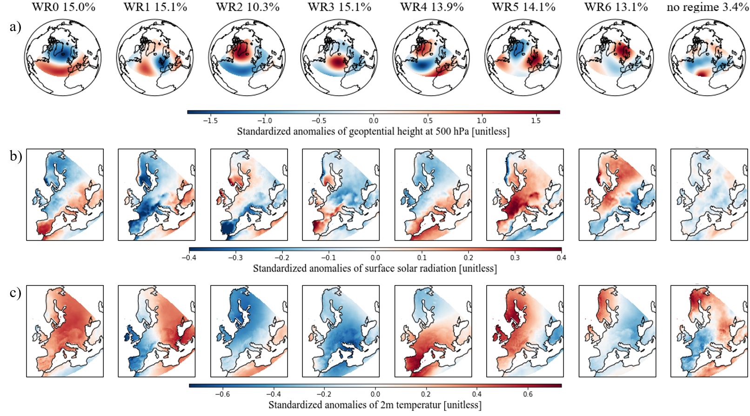

Figure 3: Different variables of the derived seven weather regimes and no regime plus their frequency of occurrence. a) Standardized anomaly fields of geopotential height at 500 hPa. b) Standardized anomaly fields of surface solar radiation. c) Standardized anomaly fields of 2m temperature.

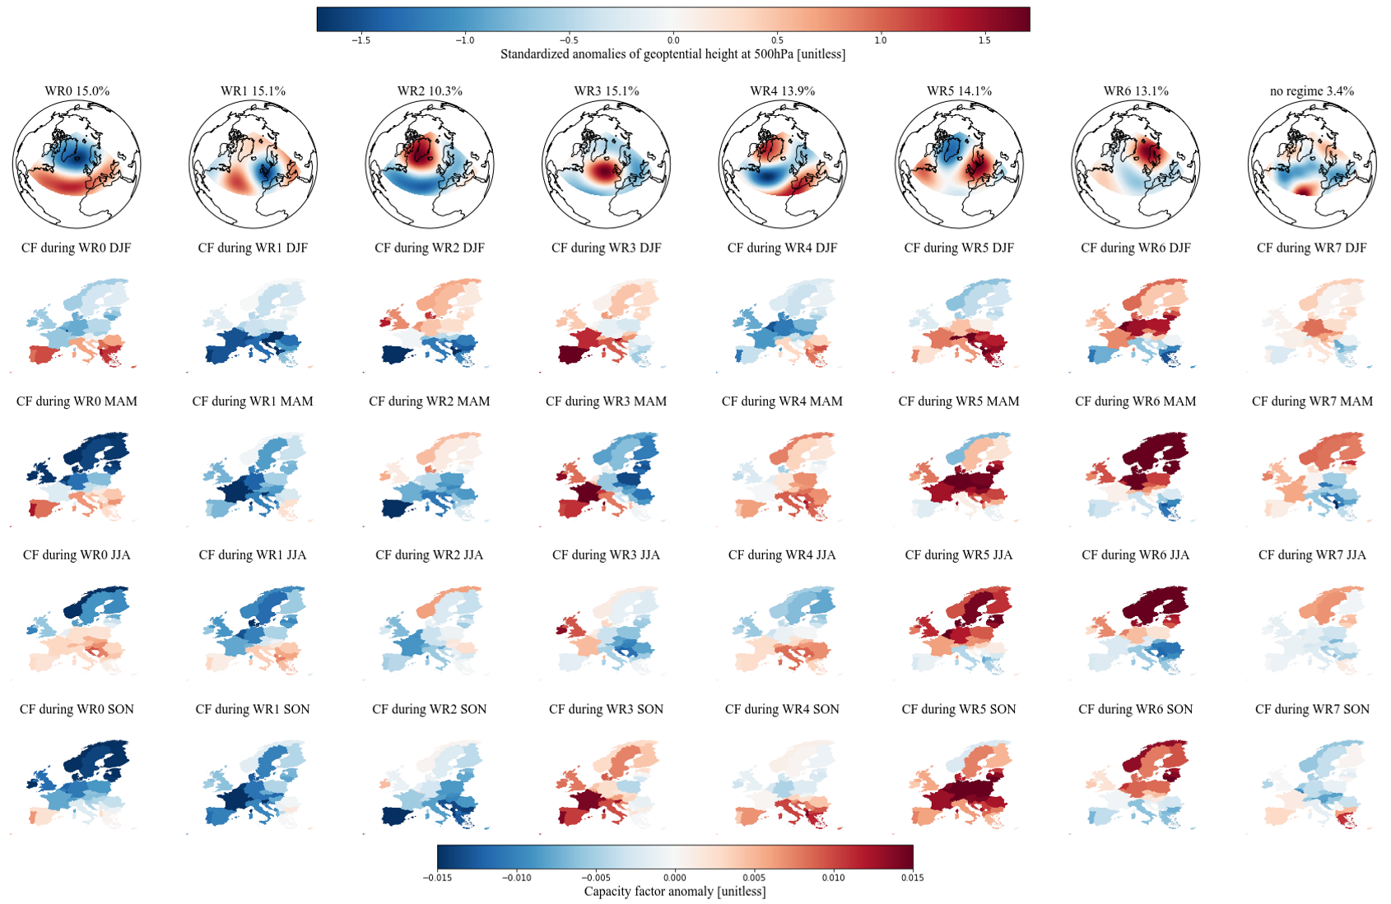

Figure 4: Link between the derived seven weather regimes (WR) and the capacity factor (CF) anomalies per country and season. The first row shows standardized anomaly fields of geopotential height at 500 hPa for each weather regime. The linked capacity factor anomalies per country are shown separately for each season and are calculated as difference to the corresponding seasonal mean: Winter (DJF), spring (MAM), summer (JJA) and autumn (SON).

Table 2: Relation between weather regime numbers and ordinary weather regime names.

|  |  |
| --- | --- |
| WR0 | Positive phase of the North Atlantic Oscillation (NAO+) |
| WR1 | European trough |
| WR2 | Negative phase of the North Atlantic Oscillation (NAO-) |
| WR3 | Atlantic ridge |
| WR4 | Atlantic trough |
| WR5 | European blocking |
| WR6 | Scandinavian blocking |

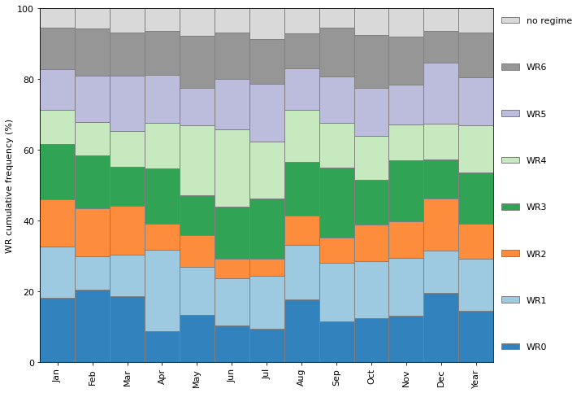

Figure : Cumulative frequency of the seven weather regimes (WR) and no regime.

### Weather regime 0 / NAO+

WR0, the positive phase of the NAO, shows a negative geopotential height anomaly (cyclone) over the Northern part of the Atlantic and a positive geopotential height anomaly (anticyclone) over the Atlantic/Mediterranean sector. During this conditions, the Atlantic storm tracks are displaced North-eastward, and the zonal flow is enhanced. This increases the strength of the westerlies and brings maritime air (warm and moist) to Central and Northern Europe (Hurrell et al., 2003; Rogers, 1997; Wallace & Hobbs, 2006). Consequently, the storm track activity over Northern Europe is enhanced, which implies a larger cloud clover fraction and therefore less available surface solar radiation. Studies by Pozo-Vázquez *et al.* (2004; 2011) indeed have shown that that the NAO index is negatively correlated with the surface solar radiation in Northern Europe and positively correlated with surface solar radiation in southern Europe. Our results agree with these studies with negative surface solar radiation anomalies in Northern Europe, positive surface solar radiation in Southern Europe and positive temperature anomalies almost all over Europe (Figure 3b) and c), first column).

The CF anomalies during the positive phase of the NAO also exhibit a clear North to South discrepancy. Northern Europe shows negative CF anomalies whereas Southern Europe is dominated by positive CF anomalies. This is in line with the surface solar radiation described above but its limpidity changes throughout the season. I.e., in spring (MAM) the results show a strong and clear difference between Southern and Northern Europe. But in autumn (SON) only the Iberian Peninsula and a few Countries in South-eastern Europe exhibit positive CF anomalies. WR0 is more frequent during winter times which may explain the change of the limpidity in the discrepancy (Error: Reference source not found).

### Weather regime 1 - European trough

WR1, the European through, is characterized by a meridional dipole of a positive and negative geopotential height anomaly in the Atlantic and Western Europe, respectively. The cyclone located over Western Europe brings relatively warm air from the South to South-eastern Europe and higher temperature than normal can be observed (Figure 3c), WR1). Surface solar radiation anomalies are also enhanced in South-eastern Europe but are not as pronounced. Western Europe, where the cyclone is located at, shows negative temperature and surface solar radiation anomalies expect the Northern part of the British Isles and the Western coast of Norway, which is already on the northern edge of the cyclone.

The CF anomalies during the European trough are mostly negative. Especially in winter (DJF) where Southern and South-eastern Europe exhibit an even larger negative impact than Northern Europe. Interestingly, this weakens in spring even turns to positive CF anomalies in summer which is more in line with our surface solar radiation anomalies presented year around. This may be caused because WR1 is less frequent in winter than summer and spring (Error: Reference source not found).

### Weather regime 2 – NAO-

WR2, the negative phase of the NAO, exhibits contrary geopotential height anomaly fields than the positive phase of the NAO. It is characterized by a negative geopotential height anomaly over the Atlantic/Mediterranean sector and positive geopotential height anomaly over Greenland. This also yields in reversed surface weather variables than the positive phase of the NAO. More available surface solar radiation than the climatological average in Northern Europe and lower surface solar radiation in Southern Europe. The temperature anomalies are negative all over Europe.

The contrary pattern to the positive NAO is also reflected in the CF anomalies with positive values in Northern Europe and negative values in the South. But we can see here as well that this discrepancy between North and South is clear in winter and spring but weakens in summer and autumn where more negative CF anomalies are present in Northern regions. Again, the cause my lie in the more frequency occurrence of WR2 during winter times (Error: Reference source not found).

### Weather regime 3 - Atlantic ridge

WR3, the Atlantic ridge, exhibits a strong positive geopotential height anomaly (anticyclone) over the Atlantic. Enhanced surface solar radiation anomalies can be seen in Western Europe, mainly over the Iberian Peninsula and over Southern Scandinavia. These regions are located at the western edge of the anticyclone. This could explain the enhanced surface solar radiation because of the relation between anticyclones and descending air and therefore clear sky conditions. Eastern Europe, which is already outside the region of the anticyclone, shows negative surface solar radiation. The anticyclone brings relatively cold air from the North to Europe and therefore one can observe negative temperature anomalies all over Europe expect the Western coast of Iberian Peninsula and the British Isles.

The East-West gradient is also visible in the CF anomalies. With positive anomalies in the West and negative anomalies in the East. But the seasonal differences are substantial. In spring (MAM) one can observe a strong East-West gradient. In winter (DJF) and autumn (SON) one can still see a discrepancy between East and West but the anomalies are less enhanced and generally more often positive. The opposite is the case for summer where one can see more often but less enhanced negative anomalies but still with an East-West gradient.

### Weather regime 4 - Atlantic trough

WR4, the Atlantic, trough, shows a meridional dipole pattern of the geopotential height anomaly reversed to WR1. But the cyclone and anticyclone are more elongated in meridional direction. The negative anomaly is located over the Atlantic and Northern Europe and the positive anomaly is located over the Mediterranean sector. It can be best compared with the Atlantic trough weather regime (i.e. GRAMS) but the positive geopotential height anomaly over South-eastern Europe does not fit well to this association. WR4 exhibits enhanced temperature anomalies over Southern and Central Europe in the region of the positive geopotential height anomaly and slightly negative temperature anomalies over Scandinavia. The surface solar radiation anomalies show a clear gradient from South-Eastern to North-Western Europe. Positive values are located over the Mediterranean region and negative values anomalies over Scandinavia and British Isles.

The CF anomalies of the countries in the Mediterranean region are like to the surface solar radiation anomalies and show mostly slightly positive values. In Northern Europe, the difference between the season is more pronounced. In winter and summer, they are negative but in autumn and especially in spring more Northern countries exhibits positive CF anomalies.

### Weather regime 5 - European blocking

WR5, the European blocking, shows a positive geopotential height anomaly (anticyclone) over Central Europe. This is associated with descending air which brings clear skies over central Europe and therefore enhanced surface solar radiation anomalies can be observed in Figure 3b, WR5. Only in the Scandinavian region and in Eastern Spain it is less pronounce or even negative because these regions are already on the edge of anticyclone. The temperature is also enhanced especially in North-Western Europe which is the region where the anticyclone brings warm air from the South northwards.

With the clear sky and warm temperature, the CF are also higher than normal. Greatly increased CF anomalies can be observed especially in central Europe. In winter, the CF anomalies are only negative for Scandinavia and the British Isles. Towards summer these changes to positive CF anomalies whereas it changes for Southern countries to negative CF anomalies.

### Weather regime 6 - Scandinavian blocking

Like the European blocking the positive geopotential height anomaly (anticyclone) over Scandinavia relates to descending air, which results in clear sky condition and therefore enhanced surface solar radiation (Figure 3b, WR6). Since the anticyclone is now located more to the North, Southern countries exhibit less surface solar radiation than normal. The positive temperature anomalies have now also shifted Northwards to the Scandinavian region. The anticyclone brings relatively cold air from the North to South-eastern Europe where a negative temperature anomaly can be observed (Figure 3c), WR6).

The CF anomalies show greatly increased values over Northern Europe throughout the whole year whereas the CF anomalies in Southern Europe are lower than normal.

### No regime

No regime (weather regimes that no not last at least 3 days) does not show a clear structure (cyclone and/or anticyclone) as WR0 to WR6 expect half of an anticyclone (due to the domain definition) in the Atlantic. Other than this anticyclone, slightly negative geopotential height anomalies dominate over the Atlantic and Southern and Central Europe. Slightly positive geopotential height anomalies can be observed in Northern Scandinavia. The anomalies are not very pronounced, which we could expect because it is the average of different weather regimes. Also, the surface solar radiation is not very pronounced but slightly negative. The 2-m temperature shows similar distribution as the geopotential height anomaly with positive values and Northern-eastern Europe and negative values in South-western Europe.

Also, the CF anomalies are not very pronounced but with slightly positive values in Northern Europe and slightly negative values in Southern Europe in winter, spring and summer. In autumn it changes, and Northern Europe has mostly slightly negative CF anomalies where Southern Europe shows more positive values.

The frequency of no regime amounts to 3.4% which indicates that only 3.4% of all analysed days are not linked to a weather regime.

## Installed capacity distributions and their variability

We hereafter present the results of the various scenarios with their IC distributions and PV power output variability. To put the results in context, they are always shown together with the IC distributions and variability of the year 2019 (Figure 5, first plot) and/or the IC distribution and variability which we estimate for the year 2030 if the plans from NECPs are fulfilled (Figure 5, second plot).

The total IC in Europe in the year 2019 was 131.2 GW (IRENA, 2020b). Its distribution is presented in the first plot of Figure 5. Most of the capacity is installed in Western Europe with Germany as leading country. The mean PV power production, estimated with the IC and the capacity factors per country, amounts to 17.5 GW (153’300 GWh for the whole year 2019). The mean variability, which is the average change of PV power production when the weather regime shifts from one to another, amounts to 0.9 GW (1 GW is roughly the amount at which a nuclear power plant operates). This is about 5.1% of the total mean production. The maximum variability, which is the difference from the weather regime with the highest PV power production to the weather regime with the lowest PV power production per season, amounts to 3.0 GW. Which is a change in PV power production of 17.1%.

The planned total IC of the year 2030 is 386.5 GW (NECPs), which is about three times as much as in 2019. Most of the installed capacity is still located in Western Europe (Figure 5, second plot). The mean estimated PV power production increases to 52.3 GW. The mean and maximum variability also roughly triples compared to the year 2019 to 2.7 GW and 8.5 GW, respectively. Which is 5.2% and 16.3% of the mean PV power production. A details overview of the variability can be found in Figure 7 and Error: Reference source not found. Where the former shows the deviation (from the season mean) of PV power production per weather regime and season and the latter shows a consolidated (over all weather regimes) view per season.

### Scenario 1 (S1) – PV power production and installed capacities from NECP 2030

Figure 5: Current (2019), planned for the year 2030 (NECPs) and resulting from scenario 1 (S1) installed PV capacity distributions. S1 minimized the variability of PV power production with the constraint that the PV power production must be equal to the PV power production estimated for the year 2030 (NECPs). Hatched countries indicate that the upper bound (potential for roof-top mounted PV systems) is reached.

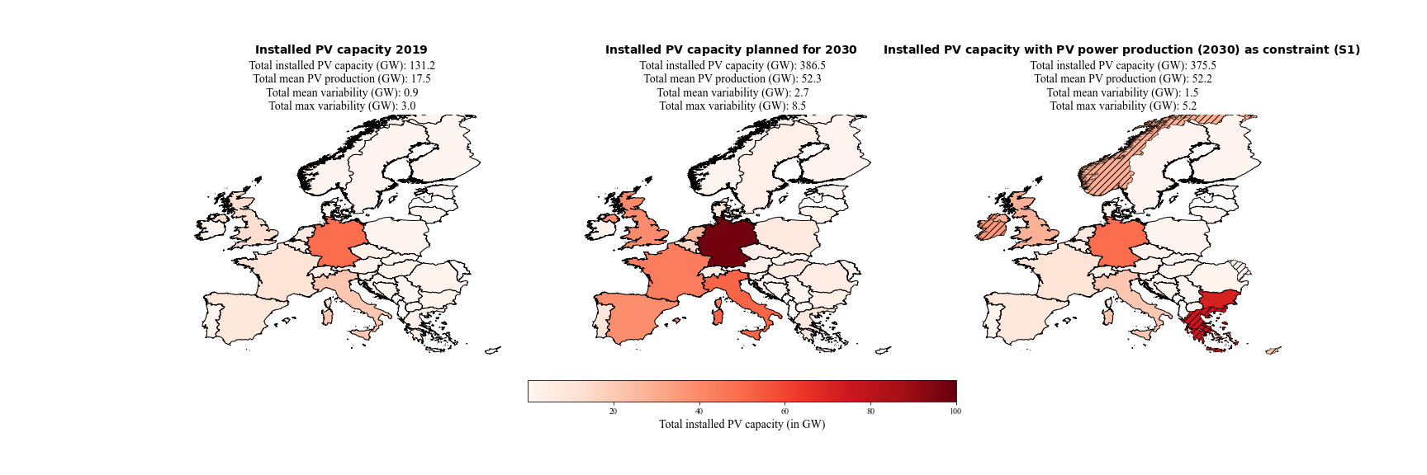The IC distribution derived under the conditions of S1 is shown in third plot of Figure 5. The total mean PV power production is almost the same as the one estimated with NECPs for 2030 (0.1 GW difference), which was the constraint for this scenario. The mean variability could be reduced from 2.7 GW to 1.5 GW and the maximum variability could be reduced from 8.5 GW to 5.2 GW. This refers to a percentual reduction from 5.2% to 2.9% for the mean variability and from 16.3% to 10.0% for the maximum variability. The reduction of the variabilities, with keeping the PV power production constant, could be achieved with overall less total installed PV capacity of 375.5 GW (compared to 386.5 GW planned for 2030).

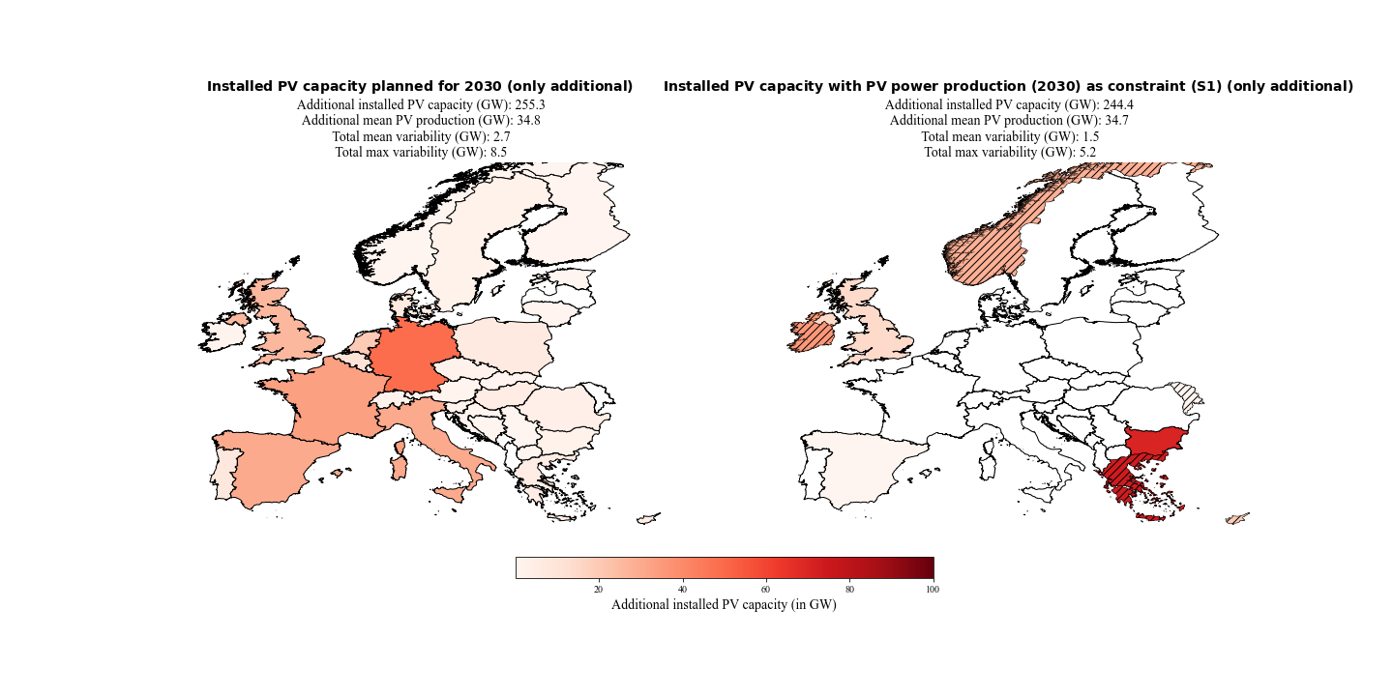Figure 6 gives an overview where the additional installed PV capacity are distributed to. It shows the difference between the total installed PV capacity estimates for 2030 and the installed PV capacity from 2019 (which is also defined as the lower bound of the linear least-square problem). Our method chosen to reduce the variability clearly favours countries in South-eastern and North-western Europe. Hatched countries signalize that the installed capacity has reached the upper bound of the linear least-square problem, which is defined as the potential for roof-top mounted PV systems.

Figure 6: Additional installed PV capacities planned for the year 2030 (NECPs) and of scenario 1 (S1). S1 minimized the variability of PV power production with the constraint that the PV power production must be equal to the PV power production estimated for the year 2030 (NECPs). Hatched countries indicate that the upper bound (potential for roof-top mounted PV systems) is reached.

A detailed impression of the over- and underproduction for every weather regime and season compared to their seasonal mean is shown in Figure 7. The IC distribution for scenario one reduces the deviation of PV power production from the seasonal mean in 25 of 32 cases. It also shows that changes from under- to overproduction in weather regimes are possible with different distributions and vice versa.

The consolidate view of the variability (Error: Reference source not found) makes clear that the variability tends to be higher in mid-season (spring and autumn). Also, the maximum variability (black markers) is higher in mid-season with the peak in autumn for all three distributions. Error: Reference source not found also shows that the distribution of S1 reduces the mean and maximum variability in in every season and in total.

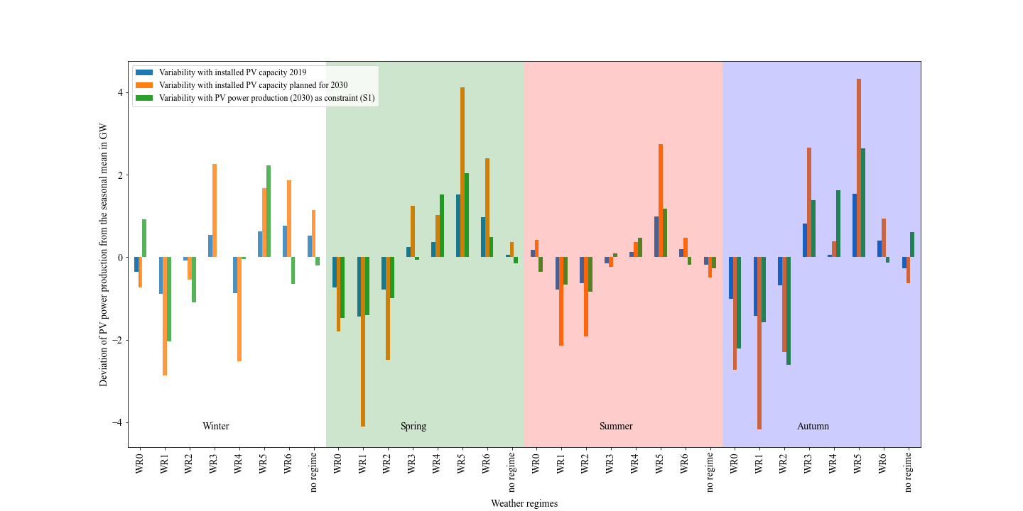

Figure 7: Deviation of the PV power production from the seasonal mean per weather regime and season. In blue the variability for the current situation (2019), in orange the estimated variability with the planned installed capacities for the year 2030 (NECPs) and in green the estimated variability with the installed capacity distribution for scenario 1.

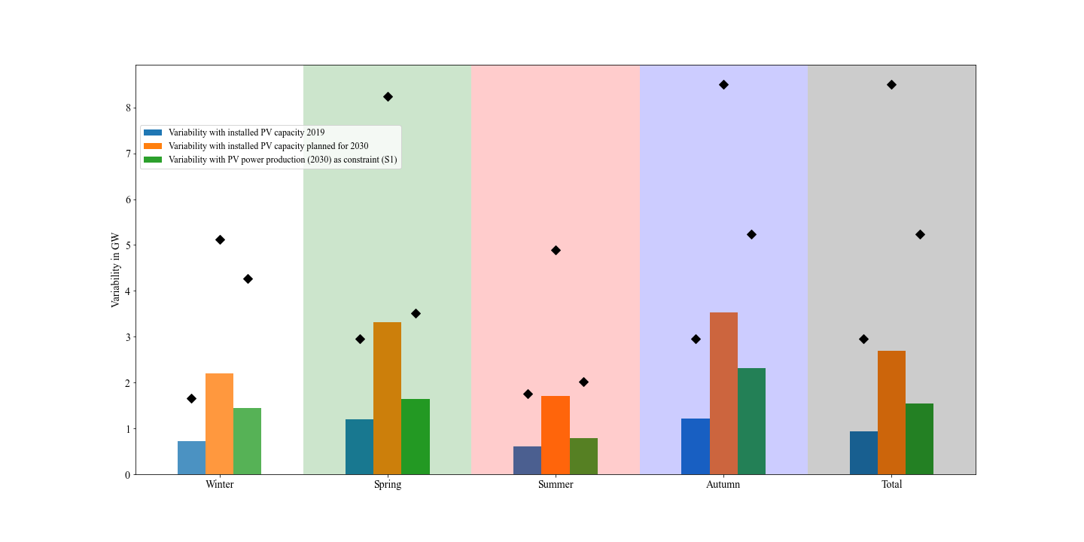

Figure : Mean (bars) and maximum (black markers) consolidated (over all weather regimes) variability per season and overall (total). In blue the variability for the current situation (2019), in orange the estimated variability with the planned installed capacities for the year 2030 (NECPs) and in green the estimated variability with the installed capacity distribution for scenario 1.

### Scenario 2 (S2) – PV IC in 2050

The results of the three folded scenario two are shown in Figure 8. The top panel refers to the scenario calculated with the lowest estimate of 0.891 TW for the year 2050 by IRENA (S2-1), the second panel refers to the scenario calculated with the middle estimate of 1.94 TW for the year 2050 by Energy Watch Group(S2-2) and the third panel refers to the scenario calculated with the highest estimated of 8.8TW for the year 2050 by SolarPower Europe (S2-3). Since the latest estimate of 8.8TW is already higher than the sum of the potential IC for roof top mounted PV panels (which is used as upper bound), we defined the upper bound for this scenario five times large. The installed capacities per country are presented as percentage of the total installed capacity, to make comparison between the three results easier. The left side of each panel shows the interpolated installed PV capacity distribution to the year 2050. The interpolation is done so that the percentage of the total IC per country remains the same as in the year 2019. Which is way all three plots looks identical, but the total installed capacity and the variability is different.

The mean change in PV power production from one weather regime to another of the interpolation is 5.4% (remains for all interpolation the same because the percentual distribution remains as well). Our method was able to reduce it to 3.3%, 3.6% and 3.5% which refers to a reduction in mean variability of 2.5 GW, 4.7 GW and 22.1 GW, respectively. The maximum changes in PV power production from one weather regime to another of the interpolation is 16.9% (remains for all interpolations the same because the percentual distribution remains as well). This could be reduced to 10.7% (S2-1), 11.9% (S2-2) and 11.6% (S2-3) which refers to a reduction in maximum variability of 7.4 GW, 13.1 GW and 63.0 GW, respectively.

In the distributions of S2, South-eastern and North-western countries are still favoured (as in S1). But Spain and Italy also get a share of the capacities. Since the total installed capacities are much higher than in scenario one, the upper bounds of the countries are more often reached (hatched countries). The method reacts on that with placing the capacities to neighbouring. This can also be seen by a comparison of S2-1 (Figure 8, first row) and S2-2 (Figure 8, second row). With higher total installed capacities, the upper bounds are more often reached and mostly neighbouring countries receive the remaining capacities and the distribution gets flatter.

Since the upper bounds and the total installed capacity are both roughly five times higher in S2-3 (Figure 8, third row) than in S2-2 (Figure 8, second row), the distributions look very similar.

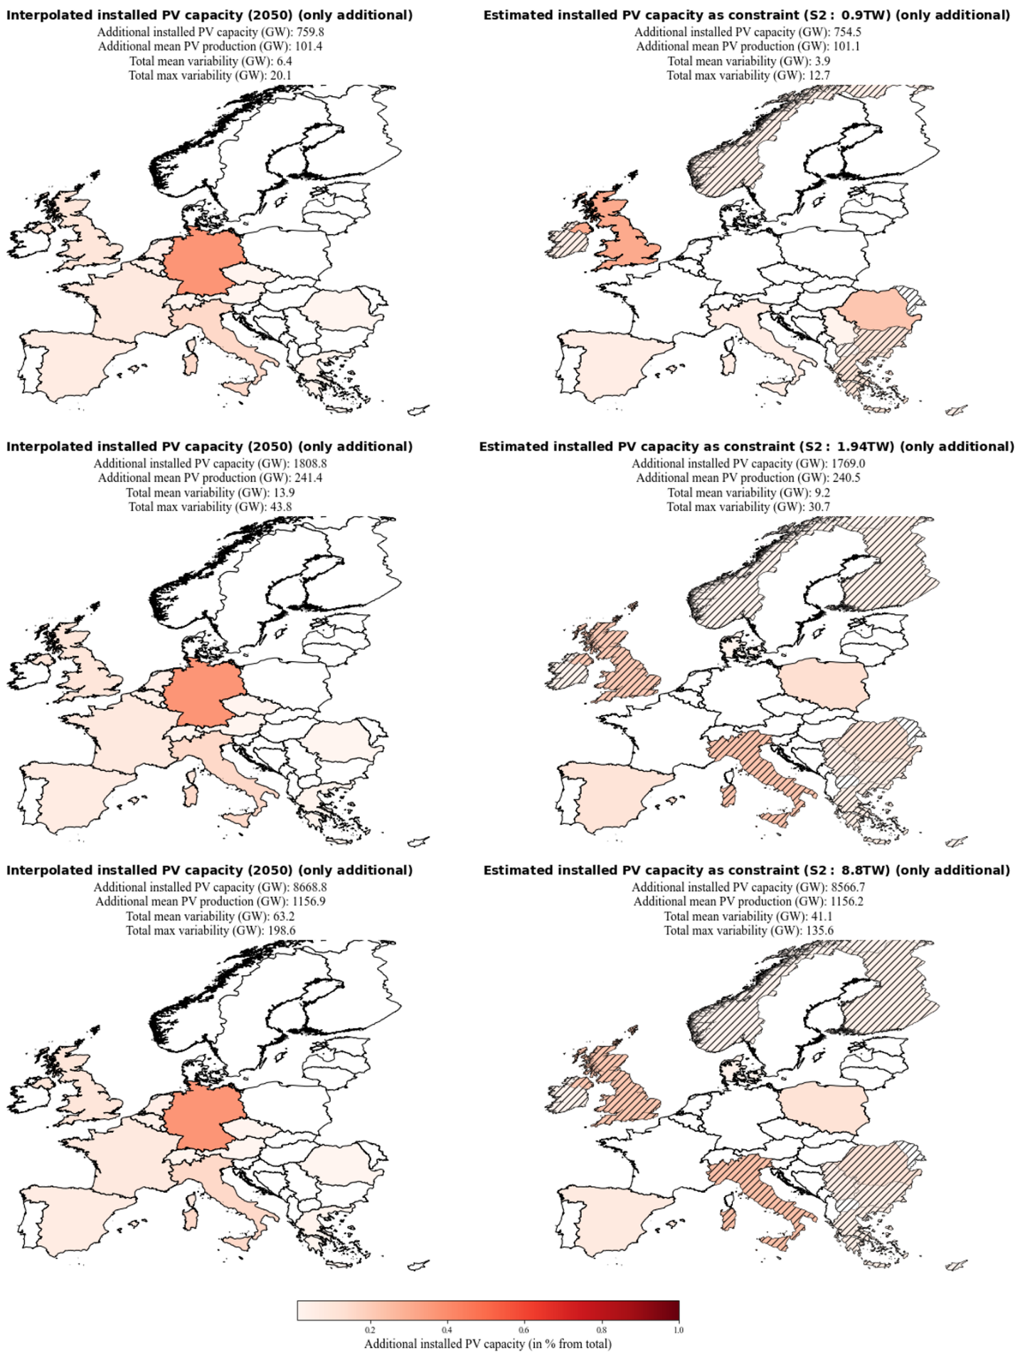

Figure 8: Additional installed PV capacities of 2050 (interpolated from the distribution of 2019) and of scenario 2-1, 2-2 and 2-3. Scenario 2-1, 2-2 and 2-3 minimize the variability of PV power production with the constraint that the power production must be equal to the PV power production estimated with the interpolations for the year 2050. Basis for the interpolation are the estimates by IRENA, Energy Watch Group and SolarPower Europe. Their estimated needed total installed PV capacity are 0.891 TW, 1.94TW and 8.8 TW for the year 2050. Hatched countries indicate that the upper bound (potential for roof-top mounted PV systems) is reached.

### Scenario 3 (S3) – Cost minimization

Figure 9: Additional installed PV capacities planned for the year 2030 (NECPs) and of scenario 3 (S3). S3 minimized the variability of PV power production and the installed PV capacities with the constraint that the power production must be equal to the power production estimated for the year 2030 (NECPs). Hatched countries indicate that the upper bound (potential for roof-top mounted PV systems) is reached.

With the focus on cost and variability minimization, we see a shift from the South-Eastern / North-western distribution (S1) to a South-eastern / South-western distribution (Figure 9, second plot). The mean variability could still be reduced from 2.7 GW to 1.8 GW (1.5 GW in S1). Which means that the mean variability reduction potential gets reduced from 44.4% (S1) to 33.3% (S3). The maximum variability could be reduced from 8.5 GW to 6.2 GW (5.2 GW in S1). Which decreases the reduction potential from 38.8% (S1) to 27.1%. The benefit of S3 is that it takes 35.9 GW less installed PV capacity to produce the same amount of electricity compared to S1.

By doing the same analysis with the estimate of 1.94TW for the year 2050 (Europe Watch Group, S2-2), we get the distribution shown in Figure 10. The method now places all the installed capacities to Southern countries. The mean variability gets reduced from 13.9 GW to 11.9 GW (9.2 GW in S2-2) and the maximum variability gets reduced from 43.8 GW to 35.0 GW (30.7 GW in S2-2). Which is a decrease of the mean variability reduction potential from 33.8% (S2-2) to 14.4% and a decrease of the maximum variability reduction potential from 29.9% to 20.1%. S3-2 needs 166.8 GW less installed capacity to produce on average 4.4 GW more electricity than S2-2.

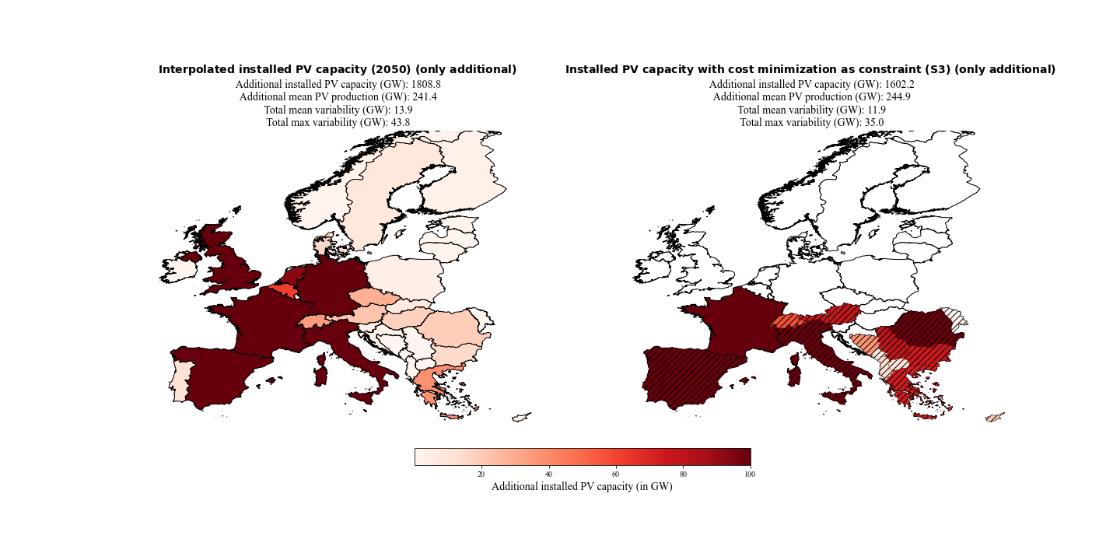

Figure 10: Additional installed PV capacities of 2050 (interpolated from the distribution of 2019 with the estimate of 1.94 TW installed PV capacity by the Energy Watch Group) and of scenario 3 (S3). S3 minimized the varability of PV power production and the installed PV capacities with the contraint that the power production must be equal to the power production estiamted for the year 2050. Hatched countries indicate that the upper bound (potential for roof-top mounted PV systems) is reached.

### Scenario 4 (S4) –Coverage of country specific electricity consumption with PV systems

S4-1 enforces a flatter distribution because of the constraint that 10% of the country specific consumption must be produced with PV systems in the year 2030. 10% are chosen because already 13.5% of the sum of the latest available consumption data for each country equals the PV power production estimated for the year 2030 with the NECPs. And if we overshoot the total installed capacity from the NECPs a comparison would not be feasible.

The results are shown in Figure 11. All countries get their needed installed capacities to cover 10% of their consumption and the rest is again distributed to South-eastern and North-western Europe. The flatter distribution is at the expense of the variability reduction potential. It reduces from 44.4% (S1) to 29.6% for the mean variability and reduces from 38.8% to 29.4% for the maximum variability. Which means that we are reducing the total mean variability from 2.7 GW to 1.9 GW (1.5 GW in S1) and the total maximum variability from 8.5 GW to 6.0 GW (5.2GW in S1).

Interesting remark → with 13.5% → nearly same variability with bit more IC and same production

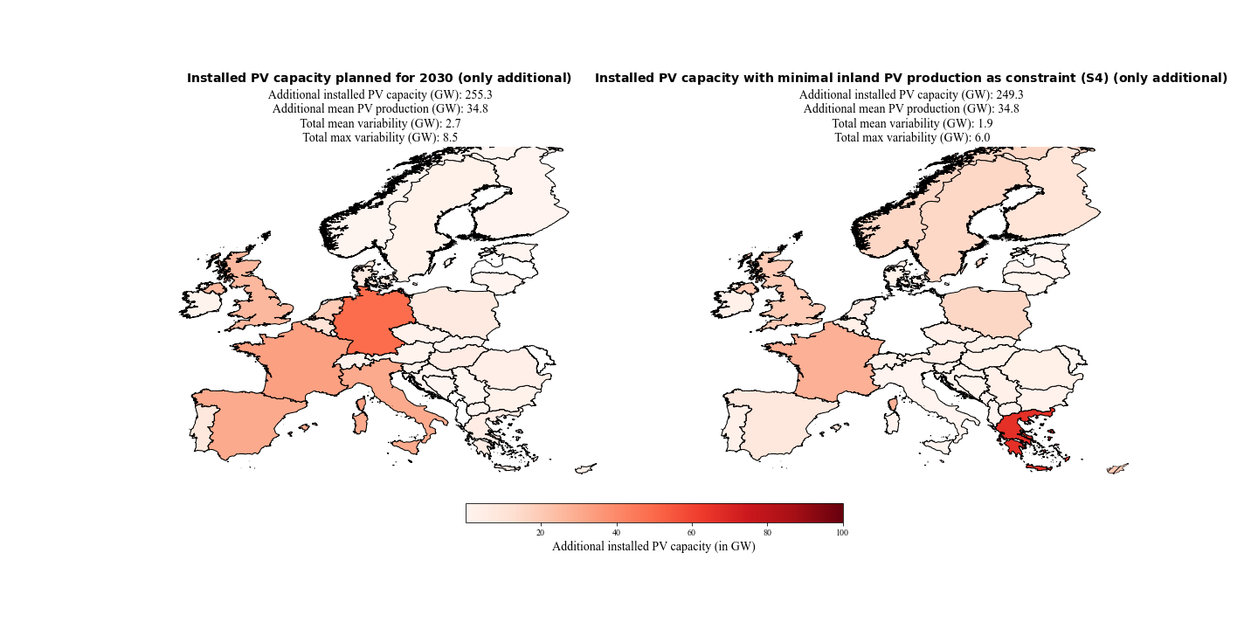

Figure 11 Additional installed PV capacities planned for the year 2030 (NECPs) and of scenario 4-1 (S4-1). S4-1 minimized the varability of PV power production with the contraint that the PV power production must be equal to the PV power production estiamted for the year 2030 (NECPs) and 10% of the inland electricity consumptions must be coverd with PV power production by the countries themselfe.

The same analyses but with the estimate of 1.94 TW installed capacity for the year 2050 by the Energy Watch Group and the constraint that 30% of the consumption per country must be covered with PV power production, yields to the results presented in Figure 12. The flatter distribution is again at the expense of the mean variability reduction potential. It decreases from 33.8% (S2-2) to 28.1%. Which is a reduction from 13.9 GW to 10.0 GW (9.2 GW in S2-2). Interestingly the maximum variability reduction potential increases within this scenario from 29.9% (S2-2) to 30.4%. Which is a reduction from 43.8 GW to 30.5 GW (30.7 GW in S2-2).

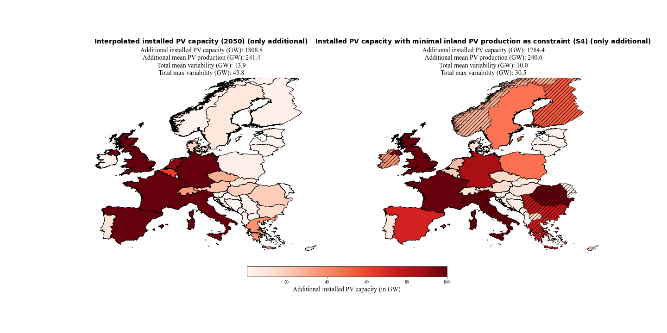

Figure 12: Additional installed PV capacities of 2050 (interpolated from the distribution of 2019 with the estimate of 1.94 TW installed PV capacity by the Energy Watch Group) and of scenario 4-1 (S4-1). S4-1 minimized the varability of PV power production with the contraint that the PV power production must be equal to the PV power production estiamted for the year 2050 and 30% of the inland electricity consumptions must be coverd with PV power production by the countries themselfe. Hatched countries indicate that the upper bound (potential for roof-top mounted PV systems) is reached.

An overview of all the important results of the various scenarios can be found in Error: Reference source not found. A detailed analysis of the over- and underproductions for every weather regime and season compared to their seasonal mean for all scenarios is shown in the appendix FIXXY – FIX XY. And the consolidate view of the variabilities for every scenario can also be found in the appendix FIXXY – FIXXY.

|  |  |  |  |  |  |  |  |  |  |  |  |
| --- | --- | --- | --- | --- | --- | --- | --- | --- | --- | --- | --- |
|  | 2019 | 2030  NECP | 2050 1.94TW | S1 | S2-1 0.891TW | S2-2 1.94TW | S2-3 8.8TW | S3-1 2030 | S3-2 2050 | S4-1 2030 | S4-2 2050 |
| Total Installed PV capacity  [GW] | 131.2 | 386.5 | 1940.0 | 375.5 | 885.6 | 1900.2 | 8697.8 | 339.6 | 1733.4 | 380.4 | 1915.6 |
| Total mean PV production  [GW] | 17.5 | 52.3 | 258.9 | 52.2 | 118.6 | 258.0 | 1173.7 | 52.3 | 262.4 | 52.3 | 258.1 |
| Total mean variability  [GW] | 0.9 | 2.7 | 13.9 | 1.5 | 3.9 | 9.2 | 41.1 | 1.8 | 11.9 | 1.9 | 10.0 |
| Total max variability  [GW | 3.0 | 8.5 | 43.8 | 5.2 | 12.7 | 30.7 | 135.6 | 6.2 | 35.0 | 6.0 | 30.5 |
| Mean variability / PV production  [%] | 5.1% | 5.2% | 5.4% | 2.9% | 3.3% | 3.6% | 3.5% | 3.4% | 4.5% | 3.6% | 3.9% |
| Max variability / PV production  [%] | 17.1% | 16.3% | 16.9% | 10.0% | 10.7% | 11.9% | 11.6% | 11.9% | 13.3% | 11.5% | 11.8% |
| Mean variability reduction  [GW] | - | - | - | 1.2 | 2.5 | 4.7 | 22.1 | 0.9 | 2.0 | 0.8 | 3.9 |
| Max variability reduction  [GW] | - | - | - | 3.3 | 7.4 | 13.1 | 63.0 | 2.3 | 8.8 | 2.5 | 13.3 |
| Mean variability reduction  [%] | - | - | - | 44.4% | 39.1% | 33.8% | 35.0% | 33.3% | 14.4% | 29.6% | 28.1% |
| Max variability reduction  [%] | - | - | - | 38.8% | 36.8% | 29.9% | 31.7% | 27.1% | 20.1% | 29.4% | 30.4% |

Table 3: Overview of all important variables of the various scenarios and their reference data.

## Notes

To meet the EU’s energy and climate targets for 2030, EU Member States need to establish a 10-year integrated national energy and climate plan (NECP) for the period from 2021 to 2030. I

2030 data → IRENA → plus missing countries!!?? → CH, UK

CF pro land vergleichen --> Doris Ide --> wie viel PV brauche ich für gleiche proiduktion in zb sweden than greece

CF pro land vergleichen --> Doris Ide --> wie viel PV brauche ich für gleiche proiduktion in zb sweden than greece

→ disupted by Colantuono 2014 and francois 2016 → nachlesen! NAO and solar radiation

WR3 → According to Wiel et al the impact of the Atlantic ridge on 2m temperature and wind are close to normal and therefore have a small impact on the energy sector. Nevertheless, his results also showed that the surface solar radiation over the Iberian Peninsula is higher than on average and over north-eastern Europe the surface solar radiation is slightly reduced.

* + Einzelne ländern nullen

# Discussion

Our results suggest that with the derived seven weather regime for Europe it is possible to assess PV power production variability year around. With that as basis we estimate for the first time how the PV power output variability could change towards the year 2030 and 2050 with the current plans for additional installed PV capacities in Europe. Furthermore, the results show that we successfully introduce a novel method to analytically find a distribution of installed PV capacities, which reduces the PV power output variability. The derived results of the four scenarios also emphasize how easily the method can be extended to implement additional constraints. In the following chapter we compare confront? Discuss in the light of existing literature? Put into the context of existing studies / literature? the obtained results with literature, highlight main findings and possible implications and hint to limitations of the chosen method. We start with the classification of WRs, as they form the basis for any further analysis, then proceed to WR associated PV production and its variability under present day conditions,before finally returning to the initial motivation of this study: in a future where energy production will be dominated by renewables,, to what degree can WR associated variability of PV power production be counteracted by different measures, such as clever spatial distribution of future PV panals or combination with wind energy.

## Weather regimes classification

Although the weather regime classification is year around, our defined seven weather regimes include the four weather regimes which are found by many studies that focused only wintertime weather regime classification (Cassou, 2008; Michelangeli et al., 1995; van der Wiel et al., 2019; Vautard, 1990). Namely the positive phase of the NAO (WR0), the negative phase of the NAO (WR2), the Atlantic ridge (WR3) and the Scandinavian blocking (WR6). Their frequencies (Error: Reference source not found and appendix Table 5) suggest that we are in line with these studies because they occur most often in winter, expect the Scandinavian blocking. The most likely explanation for this is, that the European blocking belongs to the top four weather regime during wintertime in our analysis instead of the Scandinavian blocking. Since these two weather regimes are similar, one might be at the expense of the other because we are splitting them into two separate weather regimes. A comparison with the seven weather regimes defined year around by Grams et al. (2017) shows that they mostly agree with our weather regime classification. The comparison turns out to be challenging because although Grams et al. (2017) defined the weather regimes year around, he presents the weather regime results only for wintertime. His results also include the four already discussed weather regimes (in his study with slightly different naming convention). But contrary to our frequencies during wintertime his frequencies does not determine them as the most frequent ones in winter. In addition to those four weather regimes, he determined the three weather regimes Atlantic trough, European blocking, and Scandinavian trough. The European blocking is in line with our findings. Whereas the Scandinavian trough in his study is mostly comparable with the European trough in our study. But as the names states the cyclone in his study is located over Scandinavian and, in our study, over North-western Europe. Additionally, the meridional dipole is more pronounced in our results. The Atlantic trough is in good agreement with Grams et al. (2017) results. But the positive geopotential height anomaly in Southern Europe in our study is more pronounced. The differences are most likely be explained because Grams et al. (2017) results only show the results of the weather regimes during wintertime and because some details within the chosen method to classify the weather regimes differ. The difference in the definition of the reference climatology (30- vs. 90-day running mean) and the differences in the assignment of days to no regime should be emphasized here. Overall, the weather regimes classification is in accordance with findings reported by others (Cassou, 2008; Grams et al., 2017; Michelangeli et al., 1995; van der Wiel et al., 2019; Vautard, 1990).

## Capacity factor anomalies and surface weather variables

The surface weather variables anomalies (solar radiation and 2m temperature) and in direct consequence the CFs anomalies are in good agreement with other studies. Especially the four well studied weather regimes in wintertime are line with previous results. (Bloomfield et al., 2020; Grams et al., 2017; Jones et al., 2020; Pozo-Vazquez et al., 2011; van der Wiel et al., 2019). A more detailed discussion about the seven weather regimes can be found in the next seven paragraphs.

The results of the **positive phase of the NAO (WR0)** suggests a negative correlation to the surface solar radiation anomalies in Northern Europe and a positive correlation in Southern Europe (Figure 3). Consequently, the CF anomalies behave similarly: during a positive phase of the NAO, Southern Europe experiences a relative surplus in PV production, whereas PV production is below average in Northern Europe.. The correlation between NAO+ and surface solar radiation is in agreement with the study by Pozo-Vazquez et al. (2011) although it is disputed by Colantuono et al., (2014). The observed North-South gradient of the PV CF anomalies can also be observed in the study by Grams et al. (2017). And the changes throughout the seasons are consistent with them as well. The study by Van Der Wiel et al. (2019), which only focus on wintertime, stated that the surface solar radiation is close to normal during the NAO+. But a slightly North-South gradient can also be observed in their results. Our results partly agree with those, as the discrepancy between North and South decreases in winter compared to the rest of the year.

The observed negative correlation between the **negative phase of the NAO (WR2)**, the surface solar radiation and consequently the CFs anomalies in Northern Europe (negative correlation for Southern Europe) tends to be more accepted. Which also applies to the observed overall negative temperature anomaly in Europe. (Grams et al., 2017; Hurrell et al., 2003; Jerez et al., 2013; Pozo-Vazquez et al., 2011; van der Wiel et al., 2019). Van der Wiel et al. (2019) identified that the combination of low temperature and lower than average wind speed during the NAO- is at the risk that the demand of electricity increases the supply of electricity in Europe. Since the CF are enhanced during NAO- in Northern Europe it might be a possibility to reduce that risk with additional installed PV capacities in this region.

The enhanced surface solar radiation and capacity factor anomalies in South-western Europe during the **Atlantic ridge (WR3)** matches well with Grams et al. (2017) and van der Wiel et al. (2019). Although the temperature anomalies in winter found by van der Wiel et al. (2019) are less pronounced compared to our temperature anomalies defined year around. But the changes throughout the season of the CF anomalies are rather high which gives reason to assume that the surface weather variables also are. Our identified changes throughout the seasons are mostly in line with Grams et al. (2017).

The anticyclone over Scandinavian during the **Scandinavian blocking (WR6)** brings higher than normal surface solar radiation to Northern Europe. The enhanced surface solar radiation caused by descending air and therefore clear sky condition is line with the study Amajama (2016). The resulting higher than normal 2m temperature and CFs anomalies, which is relatively constant for all seasons, are also observed by Grams et al. (2017) and van der Wiel et al. (2019).

These observations also hold for the **European blocking (WR5)**. Generally we see enhanced surface solar radiation anomalies and therefore enhanced CF anomalies in Central Europe where the Anticyclone is located (in line with Amajama, (2016)). The seasonal change is more pronounced which partly agrees with Grams et al. (2017). The change from slightly positive CFs anomalies in Southern Europe in winter to slightly negative values in summer fits to the observation by Grams et al. (2017). In contrast they do not fit for Northern countries. It was found that the CF anomalies are slightly negative in winter, whereas on the other hand Grams et al. (2017) found strongly positive values. The reason for the difference is not yet clear. One could argue that the seasonal cycle has a strong influence during this weather regime in our study. Positive CF anomalies in winter are mostly pronounced in Southern Europe. But a northward shift towards summer can be observed and again southward shift in autumn, which is likely to be explained by the seasonal cycle of surface solar radiation. This obvious and strong influence of the seasonal cycle cannot be observed in the other weather regime and their CF anomalies.

The surface solar radiation and CF anomalies of the **European through (WR1)** do agree to an large extend with the Scandinavian through defined by Grams et al. (2017). Also, the changes throughout the season matches well. Main differences arise from Southern countries which tend to be more negative within our study in wintertime. This could be explained with the position of the cyclone which in our results are located more to the South. A comparison with study by Jones et al. (2020), who investigated in the impact of 29 Grosswetterlagen on the European Energy Sector, show that the PV power production anomalies of the Grosswetterlage TRW (trough Western Europe) and TM (through Central Europe), which are mostly comparable with the European through from our analyses, are more in line with our results.

The **Atlantic trough (WR4)** is the weather regime which agrees worst with the weather regimes defined by Grams et al. (2017). Mainly because of the positive geopotential height anomaly in Southern Europe which in our results are more pronounced. Therefore, it could be expected that the CFs anomalies and weather variables also do not fit well. Indeed the surface solar radiation and the CF anomalies in South-eastern Europe are higher than normal within our study contrary to those reported by Grams et al. (2017). This is more in line with the study by Jones et al. (2020) who also suggest positive solar power production anomalies in South-eastern Europe during the Grosswetterlagen SWZ (cyclonic South-westerly) and SWA (anticyclonic South-westerly), which are relatable to the Atlantic trough. The negative surface solar radiation anomalies observed by Grams et al. (2017) for Northern countries fit again with our observed surface solar radiation anomalies. And the negative CF anomalies in Northern Europe in winter is in good agreement as well. But our results suggest that the already more positive CF anomalies in South-eastern Europe extend northwards during spring and autumn. This partly agrees with Grams et al. (2017) where the CF anomalies increases towards summer as well.

## Current and projected PV power production variability

Since the power production of PV is still relatively small compared to the power production of wind turbines in Europe, there are not many studies that focus on its variability. Therefore, we mainly compare our results with the study by Grams et al. (2017) who analysed its current variability but did not further investigate in its reduction potential for the same reason. An overview of the comparison between ours and Grams et al. (2017) results can be found in Table 4. They are presented in such a way that the difference in the total installed PV capacity is considered (131.2GW in 2019 vs. 87.91GW in 2015).

Table 4: Comparison of PV power production and variability with the study by Grams et al. (2017).

|  |  |  |  |  |
| --- | --- | --- | --- | --- |
|  | Winter | Spring | Summer | Autumn |
| PV power production / PV installed capacity  2019 | 6.6% | 16.5% | 19.6% | 10.7% |
| PV power production / PV installed capacity  Grams et al. (2017) | 6.8% | 16.7% | 19.7% | 10.9% |
| Maximum variability / PV power production 2019 | 19.3% | 13.6% | 6.8% | 21.1% |
| Maximum variability / PV power production Grams et al. (2017) | 31.8% | 17.7% | 5.1% | 23.8% |

The PV power production divided by the PV installed capacity are nearly identical. Which could be expected since the data source for the CF are the same and the percentual distribution of installed capacities from 2015 to 2019 in Europe did not change dramatically. Although the change in percentual distribution has not changed much it might explain the small differences in the results.

The estimated variability does not fit as well as the production. But the pattern from spring, to summer, to autumn are alike and generally of similar sizes. The result for winter shows a greater difference. The reason is not yet clear. But since PV power production is lowest in winter anyhow, and therefore also the absolute variability, it might play a less important role for general variability optimization considerations.

A closer look at the weather regimes with the highest overproduction shows that it is always during WR5 (European blocking) expect for winter where it is during WR6 (Scandinavian blocking). This is in line with Grams et al. (2017) who also have highest overproduction mainly during blocking situations. The lowest underproduction occurs always during WR1 (European through) which is more divers in Grams et al. (2017) study. An overview of the over- and underproduction per weather regime and season can be found in Figure 7 and in the appendix Table 6. It is worth mentioning that if a weather regime exhibits over- or underproduction it does so throughout the whole season. This gives rise to group the weather regimes accordingly. Weather regimes with a positive geopotential height anomaly (anticyclone, blocking) over the Atlantic or Continental Europe (WR3, WR4, WR5 and WR6) usually exhibits overproduction (expect WR4 winter and WR3 summer). The positive and negative phase of the NAO (WR0 and WR2) or weather regimes with negative geopotential height anomalies over Europe (cyclone) usually exhibits underproduction (expect WR0 summer). This general over- or underproduction patterns per weather regimes also shows one limit of the chosen method. The aim of the method is to align the PV power production per weather regime and season to the mean PV power production per season. But for weather regimes like e.g., WR1, which has almost everywhere negative CF throughout the whole season, this is not feasible. In other words, a gradient of the CF anomalies throughout Europe is needed that the method can achieve its aim of reducing the PV power production variability.

The estimates for the year 2030 and especially for the year 2050 shows that the PV power production variability can become substantial for the electricity grid. Grams et al. (2017) stated that it needs a tenfold of PV installed capacity to compete with the wind turbine power production variability. According to the plans by NECPs installed PV capacity for the year 2030 already triples. Our results suggest that this could lead to a variability of 8.5 GW which already has an impact on the estimates for wind power production variability of 51.7 GW for the year 2030 (Grams et al., 2017). The estimates for a 100% renewable energy – power sector by the Energy Watch Group, which is the source for our S2-2, suggest that the PV installed capacity must increase 19 times from the year 2015 until the year 2050. Whereas a quadruple increase is projected for wind installed capacity. This shows that towards 2050 PV power production becomes more competitive. If we simply interpolate that linearly to the variability, we end up with 54 GW for PV power production variability (which is comparable to our estimates of 43.8 GW, S2-2) and 93GW for wind power production variability.

The results suggest that with the current planning strategies for 2030 there will be a need for energy system operators to take the fluctuation of 8.5 GW electric power caused by PV into account. In 2050 this could massively increase to 20.1 GW to 198.6 GW, depending on the scenario. The demand of electricity must always equal the production of electricity to ensure a stable power grid. This study completely neglected the electricity demand since the focus is on PV power production variability only. Others (Bloomfield et al., 2020; van der Wiel et al., 2019) analysed the stress for the energy system caused by wind and PV production and their dependency on weather. They determined that currently blocking situations on average have lower than normal power production with wind and PV and higher than normal energy demand. Our results suggest that PV power production is contrariwise higher on average during blocking situations. E.g., during the European blocking (WR5) PV power production is usually highest whereas it is lowest for wind power production (Grams et al., 2017). The stress for the energy system during blocking situations can be explained by the fact that currently wind power production is still dominating over PV power production and therefore determines the production pattern. That highlights the potential to reduce the stress for the energy system if PV power production becomes more competitive to wind power production. The anticorrelation between wind and PV power production can be used to balance the electricity grid.

## Variability reduction potential

In line with other studies, the present work shows that PV power production in Europe undergoes substantial vairaiablity on time scales of several days, due to weather regimes. Two basic situations can further be distinguished: WRs associated with both, over and under production of PV power in different parts of Europe and WRs associated with an overall over or underproduction throughout Europe. In the former case, our study shows that suitable spatial deployment of PV panels can substantially reduce the WR associated variability of PV power production, as further discussed below in Sections 4.4.1 to 4.4.4. In the later case,spatial re-distribution of PV panels is shown to help little, WR associated variability must be counteracted by other means, as discussed below. The results of the four scenarios suggest that the objective of reducing PV power production variability is best addressed by adding future installed PV capacities to South-eastern and North-western Europe. Visual analysis of the classified seven weather regimes goes along with these results. High and low geopotential height anomaly fields are eighter affecting half of Europe (e.g. WR0), often with a South-east/North-west gradient, or entire Europe with decreasing intensity on the edges (e.g. WR5). It also goes along with the anomalies of surface solar radiation and 2m temperature. Especially the distribution of surface solar radiation often shows a discrepancy between South-eastern and North-western Europe. And it still holds for the CF anomalies but here the distribution shifts a bit, and the discrepancy between North and South is more pronounced rather than East to West. This indicates that the CF pattern associated with the different weather regimes are fairly although not entirely robust to season. It might be possible to further increase the robustness to season by analysing monthly CF instead of seasonal CF. → discuss nullen der ländern

### S1 - PV power production and installed capacities from NECP 2030

The estimates of S1 show that the potential of reducing mean and maximum variability is 44.4% and 38.8%, respectively. These are the highest percentual reduction for the mean and maximum variability which were achieved within our four scenarios (). It highlights to which extend it is possible to reduce the PV power production variability since they were only constraint by minimum PV power production (equal to the PV power production estimated for 2030). A closer look at the variability per season and weather regime (Figure 7) shows that the seven cases (out of 32) where the deviation of PV power production from the seasonal mean could not be reduced, are most often related to WR4. For spring and summer, it was exclusively WR4 which could not be reduced. The changes throughout the season of WR4 (Figure 4) might explain why it is difficult to reduce the deviation of PV power production from the seasonal mean for this weather regime. In winter, the CF anomalies have the typical South-eastern / North-western pattern, which explains why the deviation from the seasonal mean is nearly vanished in winter with the IC distribution found in S1. But the CF anomalies in rest of the seasons are generally more positive (especially in spring) and no longer a distinctive South-eastern / North-western pattern.

The season where most (3) of the seven cases, where a reduction could not be achieved, occur is winter. Interestingly WR4 is not one of them and the deviation from the seasonal mean of it could be reduced to nearly zero. The reason why winter is the season in which most of these seven cases occurs might be because PV power production is generally lowest in winter. Since the linear least-square problem reduces the sum of the absolute deviation from the seasonal mean for each weather regime and season, winter with its lower PV power production is just less important than others. Unfortunately, winter is the season where electricity demand is highest and therefore PV power production variability plays an important role. This highlights another limit of the chosen method which does not take electricity demand into account.

### S2 - PV IC in 2050

From the results of scenario two it is clear how import the PV power production variability could become towards 2050. Depending on the projected installed PV capacity for 2050, the maximum variability reaches value between 20.1 GW and 198.6 GW. As mentioned earlier our method was able to reduce it to 12.7 GW – 135.6 GW. An important implication of these findings is that before further massive deployment of PV systems, one must consider if the cost for balancing the difference of this variabilities is higher or lower than the cost that would arise by investing in the expansion of the current power grid to ensure its transmission. This is also the main limitation of the presented results as the transmission of electricity is completed neglected and one unlimited power grid for Europe is assumed. The main reason to do so is that the focus of this study lies in the potential of reducing PV power production variability. There is, so to speak, the basis information of PV power production variability for further planning strategies towards a fossil free electricity generation future. It can be used as a factor to assess whether the expansion of the European power grid is worthwhile. Another reason to neglect the transmission is that it is still unclear if transmission or storage is economically more advantageous (Bremen, 2010).

The distribution of S2 (Figure 8) goes along with the distribution of S1. South-eastern and North-western countries are still favoured. But since the total installed PV capacities has increased, the upper bound of countries are more often hit (e.g. Romania), and other countries like Italy and Spain get a (bigger) share of it. This indicates that at some point the variability reduction potential is no longer best addressed by adding the installed capacities to South-eastern Europe. The result shows that this point is reached as soon as Greece and Bulgaria are (almost) at their upper bound. Afterwards the method starts to place the installed capacities to Spain (already in S1) and Italy (S2) as well. → evtl hier nochmals country nullen bringen

The reduction potentials that could be achieved with S2 are slightly lower than the reduction potential of S1. As mentioned, with the higher defined installed PV capacity of S2, the upper bound of the countries are more often hit. Therefore, the method places the installed capacities elsewhere and that comes on the expense of the variability. It can nicely be seen by comparing S2-1 and S2-2 (, Figure 8) where the installed capacities are different, but the upper bounds remain. The reduction of the mean variability decreases about 5.3% and the maximum variability decreases about 6.9% (from S2-1 to S2-2).

The distribution and reduction potential of S2-3 and S2-2 are similar because we increased the upper bounds of S2-3 three times. As mentioned, this has been done because the sum of the total installed capacity of the upper bound is already lower than the highest installed capacity assumption for the year2050 of 8.8 TW. One interpretation of this finding is that if the upper bounds and the installed capacity are increased similarly (the installed capacity of S2-3 is also roughly increased five times compared to S2-2) the distribution and reduction potential remains. Which might lead to a general optimal distribution patterns that could be linearly increased with increasing installed capacities as long as the upper bounds are not hit. Remarkable is also that the potential of roof-top mounted PV system (REF) is smaller than the highest estimates of needed installed PV capacity for the year 2050. This highlights the importance of free field mounted PV systems. Since additional free field mounted PV systems are always in competition with wind turbines the defined upper bound is based only on roof-top mounted PV systems.

### S3 - Cost minimization

The findings of scenario three highlight that reducing PV power production variability is not exclusively on the expense of the cost. It is possible to achieve the same PV power production with 18% less additional installed PV capacity and still reducing the PV power production variability (S3-1, Figure 9 and ). And the mean and maximum reduction potential of 33.3% and 27.1% is even within reach of S1 and S2. But the distribution to only three countries (Cyprus, Greece and Spain) also show its limit.

S3-2 suggests that it is getting harder to reduce the PV power production variability with higher total installed PV capacity and cost reduction considerations. A reduction in the variability could still be achieved but decreases drastically to roughly a quarter of the mean reduction potential and half of the maximum reduction potential of S2-1. Also, the benefit in reducing the cost decreases. Where S3-1 could produce the same amount electricity with 18% less additional installed PV capacity it decreases in S3-2 to 11%. The reason is probably again because the upper bounds are more often hit. This can also be seen in Figure 10 (right plot) where nearly all Southern countries are at their upper bound.

### S4 - Coverage of country specific electricity consumption with PV systems 37

The enforcement of a flatter distribution in S4, by the constraint that a certain amount of electricity consumption must be produced with PV by every country itself, indicates that a reduction of the variability is still feasible although its potential is clearly lowered. The reduction potential estimated for 2030 and 2050 are nearly identical. The most likely explanation is that in S4-1 10% of inland electricity consumptions must be covered with PV systems and in S4-2 30%. An interesting side note within this scenario is that 13.5% of the current total electrical consumption of Europe is equal to the estimates of electrical production with PV system planned for 2030. The results of S4 implies that even with a flatter distribution the potential to reduce the variability is there. This may be of interest when planning larger solar systems and their location. Even in an already present flat installed PV capacity distribution, placing a new large solar system to a key country like Greece could reduce the PV power production variability.

## Notes

**Weather variables**

**Solar radiance and 2m temperature**

* NAO+ → Pozo Vasquez negative vorrleation → disupte by colantuono an francios
* NAO- → enhanced precipitation and cloud ccover er Curtis 2016
* Scnadinavian blocking → higher ssrd but cooler temp? amajama 2016
* Atlantic ridge → weakest relation to weather variables → barrier 2014 and van der wiel
* European trough → 2m temp Bloomfield 2020

**Current and projected variability**

2030 PV → 8.5GW / 2030 Wind 51.7 GW / 2015 wind 22.4 GW

2050 PV → 20.1-198.6GW

CF does not change over time!

Where is energy system the highest

Robustness against season (Doris)

**CF**

No need for balancing is given if the demand increases or decrease opposite of the PV power production.

The easiest way to balance this fluctuation caused by PV power production is by directly using it.

General distribution

Assumption of Power grid

Which WR is it easy to reduce the variability

Cost vs. variability

Neighbouring countries

Reduction potential with selfmade electricity → potential for big power plant in key countries like GR

|  |  |  |  |  |
| --- | --- | --- | --- | --- |
|  | Winter | Spring | Summer | Autumn |
| WR0 (NAO+) / ZO | - / + | -- / - | + / + | -- / -- |
| WR1 (EUTr) / ScTr | -- / - | -- / -- | -- / - | -- / - |
| WR2 (NAO-) / GL | - / - | -- / + | - / - | - / -- |
| WR3 (AR) / AR | + / + | + / - | - / - | ++ / - |
| WR4 (AT) / AT | -- / - | + / -- | + /- | + / -- |
| WR5 (EuBl) | ++ / ++ | ++ / ++ | ++ / + | ++ / ++ |
| WR6 (ScBl) | ++ / + | ++ / ++ | + / + | + / + |

# Conclusion

We have successfully introduced a new approach to reduce PV power production variability in Europe with an analytical method. To our knowledge, this is the first study to examine PV power production variability potential with

In the present work, we could successfully assess the relation between weather regimes and PV power output variability.

Bremen 2010

* At themoment, it is not clear if transmission or storage is economically more advantageous
* Consequently, less energy from storage facilities is required to meet imbalances In case the consumption is higher than the current generation, either stored energy must be released or additional generation units must be activated. The activation of additional generation units requires that several units are operated in stand-by or in part-load. Both options are not economical for large fossil powered generation units. Nuclear power plants can not be used as they require lead times for scheduling up to 1 day. The power of small-scale gaspowered units can be increased very quickly, thus they are ideal to fulfil this kind of service. They run either with natural gas or gas from (renewable) biomass plants.

And in line with that the seasonal frequency (FIG XY) of theses weather regimes shows us that they occur more in winter than in the other seasons (nicht 100% NAOs schon aber andere nicht so).

Weather regime 1 and 4 are more difficult to assign wo well known weather regime.. But the low pressure field located a bit more southwar over the western coast of Europe. Weather regime 4 is most likely comparable with the Atlantic through. But one can clearly identify an high pressure filed in the Southern par of Europe which would be more typical fo a blocking situation. Finally, weather regime 5 is the European blocking situation which is often associated with warmen than seasonal average temperature over central Europe

Weather regime 5 is characterized by a blocking high pressure field like weather regime 5.

# Appendix

Apendixapendixapendi

|  |  |  |  |  |
| --- | --- | --- | --- | --- |
|  | Winter (DJF) | Spring (MAM) | Summer (JJA) | Autumn (SON) |
| WR0 | 19.4% | 13.7% | 12.6% | 12.4% |
| WR1 | 11.9% | 16.0% | 14.5% | 16.4% |
| WR2 | 13.9% | 10.1% | 6.2% | 9.1% |
| WR3 | 13.9% | 12.5% | 15.6% | 16.6% |
| WR4 | 9.7% | 14.3% | 17.6% | 11.7% |
| WR5 | 14.0% | 13.3% | 14.1% | 12.6% |
| WR6 | 11.4% | 13.1% | 11.8% | 14.1% |
| no regime | 5.8% | 7.0% | 7.5% | 7.0% |

Table 5: The defined seven weather regimes and no regime and their frequency throughout the season.

Table 6: Current (2019) and projected (2030) PV power production anomaly (difference to the seasonal mean) estimates per weather regime and season. The projection to 2030 is based on the National energy and climate plans (NECPs). Framed in blue are the lowest anomalies per season and framed in red are the highest anomalies per season.

|  |  |  |  |
| --- | --- | --- | --- |
|  |  | PV power production anomaly 2019 (GW) | PV power production anomaly 2030 (GW) |
| Winter Mean production: 8.6 GW | **WR0** | -0.36 | -0.74 |
| **WR1** | -0.89 | -2.87 |
| **WR2** | -0.08 | -0.55 |
| **WR3** | 0.55 | 2.26 |
| **WR4** | -0.87 | -2.52 |
| **WR5** | 0.62 | 1.68 |
| **WR6** | 0.77 | 1.87 |
| **no regime** | 0.52 | 1.15 |
| Spring Mean production: 21.7 GW | **WR0** | -0.74 | -1.80 |
| **WR1** | -1.43 | -4.11 |
| **WR2** | -0.78 | -2.49 |
| **WR3** | 0.25 | 1.24 |
| **WR4** | 0.36 | 1.02 |
| **WR5** | 1.53 | 4.12 |
| **WR6** | 0.97 | 2.40 |
| **no regime** | 0.05 | 0.36 |
| Summer Mean production: 25.7 GW | **WR0** | 0.18 | 0.42 |
| **WR1** | -0.78 | -2.15 |
| **WR2** | -0.63 | -1.92 |
| **WR3** | -0.16 | -0.24 |
| **WR4** | 0.13 | 0.36 |
| **WR5** | 0.98 | 2.74 |
| **WR6** | 0.19 | 0.47 |
| **no regime** | -0.18 | -0.49 |
| Autumn Mean production: 14.0 GW | **WR0** | -1.00 | -2.72 |
| **WR1** | -1.41 | -4.18 |
| **WR2** | -0.68 | -2.30 |
| **WR3** | 0.82 | 2.65 |
| **WR4** | 0.06 | 0.39 |
| **WR5** | 1.54 | 4.32 |
| **WR6** | 0.41 | 0.93 |
| **no regime** | -0.28 | -0.62 |

|  |  |  |
| --- | --- | --- |
|  |  | PV power production anomaly 2019 (GW) |
| Winter Mean production: 8.6 GW | **WR0** | -0.36 |
| **WR1** | -0.89 |
| **WR2** | -0.08 |
| **WR3** | 0.55 |
| **WR4** | -0.87 |
| **WR5** | 0.62 |
| **WR6** | 0.77 |
| **no regime** | 0.52 |
| Spring Mean production: 8.6 GW | **WR0** | -0.74 |
| **WR1** | -1.43 |
| **WR2** | -0.78 |
| **WR3** | 0.25 |
| **WR4** | 0.36 |
| **WR5** | 1.53 |
| **WR6** | 0.97 |
| **no regime** | 0.05 |
| Summer Mean production: 25.7 GW | **WR0** | 0.18 |
| **WR1** | -0.78 |
| **WR2** | -0.63 |
| **WR3** | -0.16 |
| **WR4** | 0.13 |
| **WR5** | 0.98 |
| **WR6** | 0.19 |
| **no regime** | -0.18 |
| Autumn Mean production: 14.0 GW | **WR0** | -1.00 |
| **WR1** | -1.41 |
| **WR2** | -0.68 |
| **WR3** | 0.82 |
| **WR4** | 0.06 |
| **WR5** | 1.54 |
| **WR6** | 0.41 |
| **no regime** | -0.28 |

# References

Amajama, J. (2016). Effect of Air Pressure on the Output of Photovoltaic Panel and Solar Illuminance ( or Intensity ). *International Journal of Scientific Engineering and Applied Science*, *2*(8), 139–144.

Bloomfield, H. C., Brayshaw, D. J., & Charlton-Perez, A. J. (2020). Characterizing the winter meteorological drivers of the European electricity system using targeted circulation types. *Meteorological Applications*, *27*(1), 1–18. https://doi.org/10.1002/met.1858

Branch, M. A., Coleman, T. F., & Li, Y. (1999). Subspace, interior, and conjugate gradient method for large-scale bound-constrained minimization problems. *SIAM Journal of Scientific Computing*, *21*(1), 1–23. https://doi.org/10.1137/S1064827595289108

Bremen, L. Von. (2010). Large-Scale Variability of Weather Dependent Renewable Energy Sources. In A. Troccoli (Ed.), *Management of Weather and Climate Risk in the Energy Industry* (pp. 189–206). Springer Netherlands.

Cassou, C. (2008). Intraseasonal interaction between the Madden-Julian Oscillation and the North Atlantic Oscillation. *Nature*, *455*(7212), 523–527. https://doi.org/10.1038/nature07286

Colantuono, G., Wang, Y., Hanna, E., & Erdélyi, R. (2014). Signature of the North Atlantic Oscillation on British solar radiation availability and PV potential: The winter zonal seesaw. *Solar Energy*, *107*, 210–219. https://doi.org/10.1016/j.solener.2014.05.045

Dawson, A. (2016). eofs: A Library for EOF Analysis of Meteorological, Oceanographic, and Climate Data. *Journal of Open Research Software*, *4*, 4–7. https://doi.org/10.5334/jors.122

Delucchi, M. A., & Jacobson, M. Z. (2011). Providing all global energy with wind, water, and solar power, Part II: Reliability, system and transmission costs, and policies. *Energy Policy*, *39*(3), 1170–1190. https://doi.org/10.1016/j.enpol.2010.11.045

Graabak, I., & Korpås, M. (2016). Variability Characteristics of European Wind and Solar Power Resources—A Review. *Energies*, *9*(6), 1–31. https://doi.org/10.3390/en9060449

Grams, C. M., Beerli, R., Pfenninger, S., Staffell, I., & Wernli, H. (2017). Balancing Europe’s wind-power output through spatial deployment informed by weather regimes. *Nature Climate Change*, *7*(8), 557–562. https://doi.org/10.1038/nclimate3338

Heide, D., von Bremen, L., Greiner, M., Hoffmann, C., Speckmann, M., & Bofinger, S. (2010). Seasonal optimal mix of wind and solar power in a future, highly renewable Europe. *Renewable Energy*, *35*(11), 2483–2489. https://doi.org/10.1016/j.renene.2010.03.012

Hennermann, K., & Yang, X. (2018). *ERA5 data documentation*. European Centre for Medium-Range Weather Forecasts. https://confluence.ecmwf.int/display/CKB/ERA5+data+documentation

Hersbach, H., Bell, B., Berrisford, P., Biavati, G., Horányi, A., Muñoz Sabater, J., Nicolas, J., Peubey, C., Radu, R., Rozum, I., Schepers, D., Simmons, A., Soci, C., Dee, D., & Thépaut, J.-N. (2018). *ERA5 hourly data on pressure levels from 1979 to present.* Copernicus Climate Change Service (C3S) Climate Data Store (CDS). https://doi.org/10.24381/cds.bd0915c6

Huld, T., Gottschalg, R., Beyer, H. G., & Topič, M. (2010). Mapping the performance of PV modules, effects of module type and data averaging. *Solar Energy*, *84*(2), 324–338. https://doi.org/10.1016/j.solener.2009.12.002

Hulme, M. (2016). 1.5 °C and climate research after the Paris Agreement. *Nature Climate Change*, *6*(3), 222–224. https://doi.org/10.1038/nclimate2939

Hurrell, J. W., Kushnir, Y., Ottersen, G., & Visbeck, M. (2003). An overview of the north atlantic oscillation. *Geophysical Monograph Series*, *134*, 1–35. https://doi.org/10.1029/134GM01

IRENA. (2020a). Global Renewables Outlook: Energy transformation 2050. In *International Renewable Energy Agency*. https://www.irena.org/publications/2020/Apr/Global-Renewables-Outlook-2020

IRENA. (2020b). *Renewable capacity statistics 2020 International Renewable Energy Agency (IRENA)*.

Jäger-Waldau, A. (2019). PV Status Report 2019. In *EUR 29938 EN, Publications Office of the European Union*. https://doi.org/10.2760/326629

Jerez, S., Trigo, R. M., Vicente-Serrano, S. M., Pozo-VáZquez, D., Lorente-Plazas, R., Lorenzo-Lacruz, J., Santos-Alamillos, F., & MontáVez, J. P. (2013). The impact of the north atlantic oscillation on renewable energy resources in Southwestern Europe. *Journal of Applied Meteorology and Climatology*, *52*(10), 2204–2225. https://doi.org/10.1175/JAMC-D-12-0257.1

Jones, S., Lee, S. R., & Bloomfield, H. (2020). *Wintertime Impacts of Synoptic-Scale Weather Patterns on the European Energy Sector* (Issue August). University of Reading.

Lauret, P., Boland, J., & Ridley, B. (2013). Bayesian statistical analysis applied to solar radiation modelling. *Renewable Energy*, *49*, 124–127. https://doi.org/10.1016/j.renene.2012.01.049

Michelangeli, P. A., Vautard, R., & Legras, B. (1995). Weather regimes: recurrence and quasi stationarity. In *Journal of the Atmospheric Sciences* (Vol. 52, Issue 8, pp. 1237–1256). https://doi.org/10.1175/1520-0469(1995)052<1237:WRRAQS>2.0.CO;2

Mills, A., & Wiser, R. (2010). Implications of Wide-Area Geographic Diversity for Short- Term Variability of Solar Power. In *Energy*. https://doi.org/10.2172/986925

Muñoz Sabater, J. (2019). *ERA5-Land hourly data from 1981 to present.* Copernicus Climate Change Service (C3S) Climate Data Store (CDS). https://doi.org/10.24381/cds.e2161bac

Pedregosa, F., Varoquaux, G., Gramfort, A., Michel, V., Thirion, B., Grisel, O., Blondel, M., Prettenhofer, P., Weiss, R., Dubourg, V., Vanderplas, J., Passos, A., Cournapeau, D., Brucher, M., Perrot, M., & Duchesnay, E. (2011). Scikit-learn: Machine Learning in {P}ython. *Journal of Machine Learning Research*, *12*, 2825–2830.

Pfenninger, S., & Staffell, I. (2016). Long-term patterns of European PV output using 30 years of validated hourly reanalysis and satellite data. *Energy*, *114*, 1251–1265. https://doi.org/10.1016/j.energy.2016.08.060

Pozo-Vazquez, D., Santos-Alamillos, F. J., Lara-Fanego, V., Ruiz-Arias, J. A., & Tovar-Pescador, J. (2011). Hydrological, Socioeconomic and Ecological Impacts of the North Atlantic Oscillation in the Mediterranean Region. In *Hydrological, Socioeconomic and Ecological Impacts of the North Atlantic Oscillation in the Mediterranean Region* (Vol. 46, Issue December 2015). https://doi.org/10.1007/978-94-007-1372-7

Pozo-Vázquez, D., Tovar-Pescador, J., Gámiz-Fortis, S. R., Esteban-Parra, M. J., & Castro-Díez, Y. (2004). NAO and solar radiation variability in the European North Atlantic region. *Geophysical Research Letters*, *31*(5), n/a-n/a. https://doi.org/10.1029/2003gl018502

Ram, M., Bogdanov, D., Aghahosseini, A., Oyewo, A., Gulagi, A., Child, M., & Fell, H.-J. (2019). Global Energy System based on 100% Renewable Energy – Power, Heat, Transport and Desalination Sectors. *Study by Lappeenranta University of Technology and Energy Watch Group*, *1*(March), 1–321.

Ram, M., Bogdanov, D., Aghahosseini, A., Oyewo, S., Gulagi, A., Child, M., & Breyer, C. (2017). Global Energy System based on 100% Renewable Energy – Power Sector. *LUT Scientific and Expertise Publications : Raportit Ja Selvitykset - Reports*.

Ridley, B., Boland, J., & Lauret, P. (2010). Modelling of diffuse solar fraction with multiple predictors. *Renewable Energy*, *35*(2), 478–483. https://doi.org/10.1016/j.renene.2009.07.018

Rogers, J. C. (1997). North Atlantic storm track variability and its association to the North Atlantic oscillation and climate variability of Northern Europe. *Journal of Climate*, *10*(7), 1635–1647. https://doi.org/10.1175/1520-0442(1997)010<1635:NASTVA>2.0.CO;2

Santos-Alamillos, F. J., Pozo-Vázquez, D., Ruiz-Arias, J. A., Von Bremen, L., & Tovar-Pescador, J. (2015). Combining wind farms with concentrating solar plants to provide stable renewable power. *Renewable Energy*, *76*(2015), 539–550. https://doi.org/10.1016/j.renene.2014.11.055

SolarPower Europe and LUT University. (2020). *100% Renewable Europe - How to make Europe’s energy system climate-neutral before 2050*. 64.

Stram, B. N. (2016). Key challenges to expanding renewable energy. *Energy Policy*, *96*, 728–734. https://doi.org/10.1016/j.enpol.2016.05.034

Sweerts, B., Pfenninger, S., Yang, S., Folini, D., van der Zwaan, B., & Wild, M. (2019). Estimation of losses in solar energy production from air pollution in China since 1960 using surface radiation data. *Nature Energy*, *4*(8), 657–663. https://doi.org/10.1038/s41560-019-0412-4

van der Wiel, K., Bloomfield, H. C., Lee, R. W., Stoop, L. P., Blackport, R., Screen, J. A., & Selten, F. M. (2019). The influence of weather regimes on European renewable energy production and demand. *Environmental Research Letters*, *14*(9), 094010. https://doi.org/10.1088/1748-9326/ab38d3

Vautard, R. (1990). Multiple weather regimes over the North Atlantic: analysis of precursors and successors. *Monthly Weather Review*, *118*(10). https://doi.org/10.1175/1520-0493(1990)118<2056:MWROTN>2.0.CO;2

Wallace, J. M., & Hobbs, P. V. (2006). *Atmospheric Science: An Introductory Survey* (2nd ed.). Amsterdam ; Boston : Elsevier Academic Press, [2006].

Wild, M., Folini, D., Henschel, F., Fischer, N., & Müller, B. (2015). Projections of long-term changes in solar radiation based on CMIP5 climate models and their influence on energy yields of photovoltaic systems. *Solar Energy*, *116*, 12–24. https://doi.org/10.1016/j.solener.2015.03.039

Comments/Notes

**Solarpowereurope** →

In 2050, solar PV alone has installed capacities between 4.7 TW in the Laggard scenario, 7.7 TW in the Moderate scenario and 8.8 TW in the Leadership scenario.

**IRNEA**

* + Solar PV could cover a quarter of global electricity needs by mid-century, becoming the second largest generation source after wind.
  + Global capacity must reach 18 times current levels, or more than 8 000 gigawatts by 2050.
  + Asia would continue to dominate solar PV use, with over 50% of installed capacity, followed by North America (20%) and Europe (10%).
  + 8000gigawatts*0.1 = 800gigawatts → in excel from IRENA 891

**Large-scale integration of renewable energies and impact on storage demand in a European renewable power system of 2050**

The results for the base scenario show a total installed generation capacity of 4,550 GW, which splits up into PV and WT in a ratio of 60:40 on global scale for the EUMENA regions. → 2730GW

**Zappa**

603-926GW je nach Szenario → Is a 100% renewable European power system feasible by 2050?

**Ec.europe.eu**

According to a recent 100% RES scenario of the Energy Watch Group, the EU needs to increase its PV capacity from 117 GW to over 630 GW by 2025 and 1.94 TW by 2050 in order to cover 100% of its electricity needs by renewable energy.

This is approximately half of the estimates (1.95TW) by Ram et al. (2017) whose study highlights the feasibility and the socio-economic viability of a transition to a 100% renewable electricity generation electricity system. → SCHNITT WIRD GEBRAUCHT???